Supplementary Fig. 2 Receiver operating characteristic plots of GAAD and GALAD algorithms (Cobas) and Elecsys AFP, AFP-L3, and PIVKA-II assays for discriminating between early- (A) and all-stage (B) HCC patients and controls. *P < 0.0001 vs. GAAD; †P < 0.0001 vs. GALAD. P-values for comparisons with other surveillance strategies were non-significant. 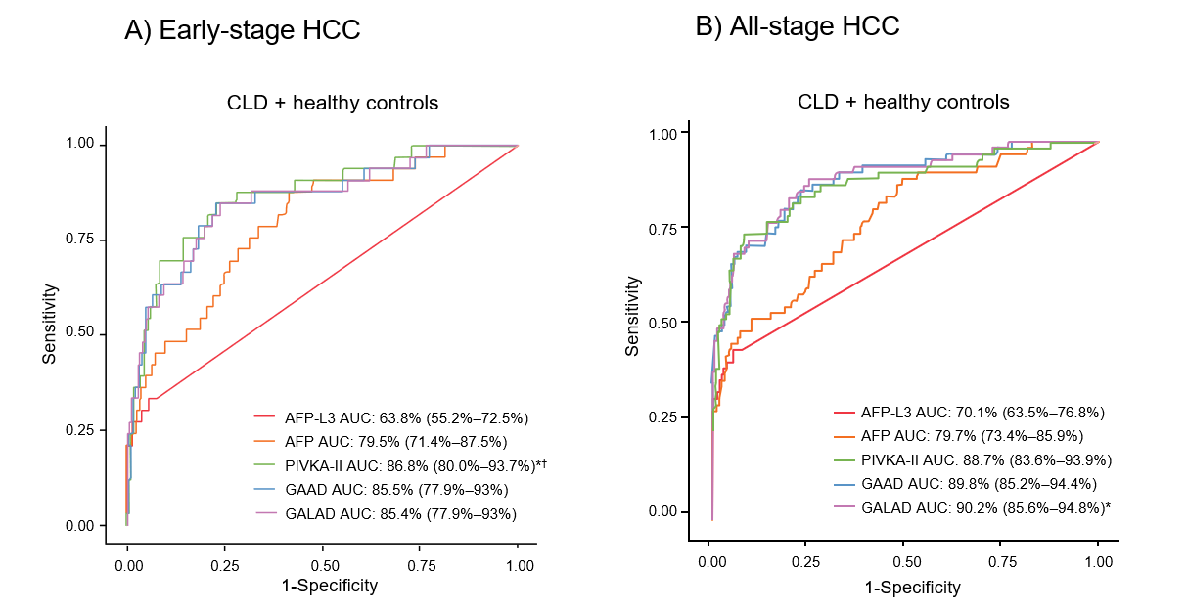
AFP, α-fetoprotein; AFP-L3, Lens culinaris agglutinin-reactive fraction of α-fetoprotein; AUC, area under the curve; CLD, chronic liver disease; GAAD, gender (biological sex), age, AFP, PIVKA-II; GALAD, gender (biological sex), age, AFP-L3, AFP, PIVKA-II; HCC, hepatocellular carcinoma; PIVKA-II, protein induced by vitamin K absence or antagonist II.

