Figure S17. Correlation between ENTPD6 expression and immune cell infiltration in hepatocellular carcinoma and other cancers.
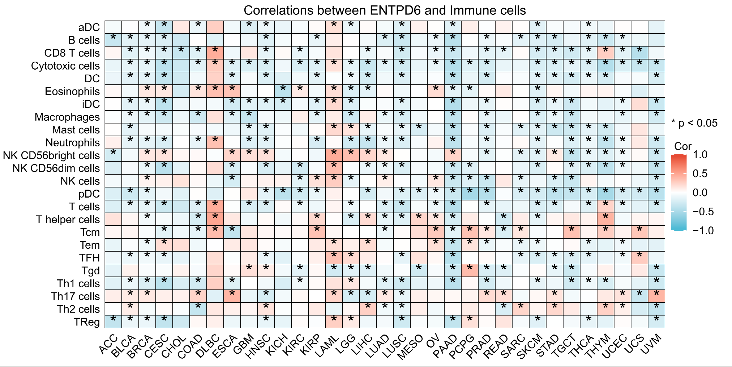
Note: LIHC, liver hepatocellular carcinoma.

