Figure S16. Association between ENTPD6 expression and overall survival in hepatocellular carcinoma and other cancer types.
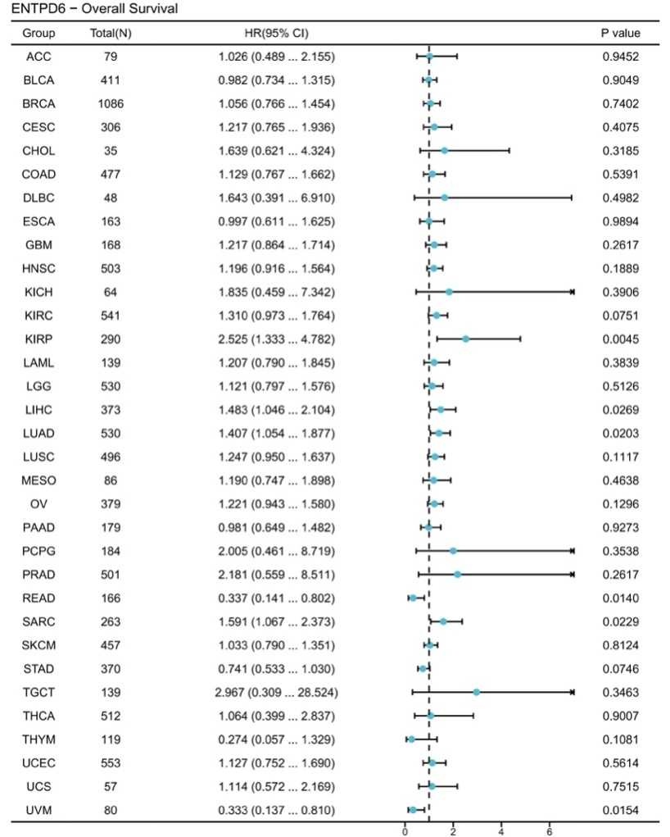
Note: LIHC, liver hepatocellular carcinoma.

