Figure S14. Correlation between CNPY4 expression and immune cell infiltration in hepatocellular carcinoma and other cancers.
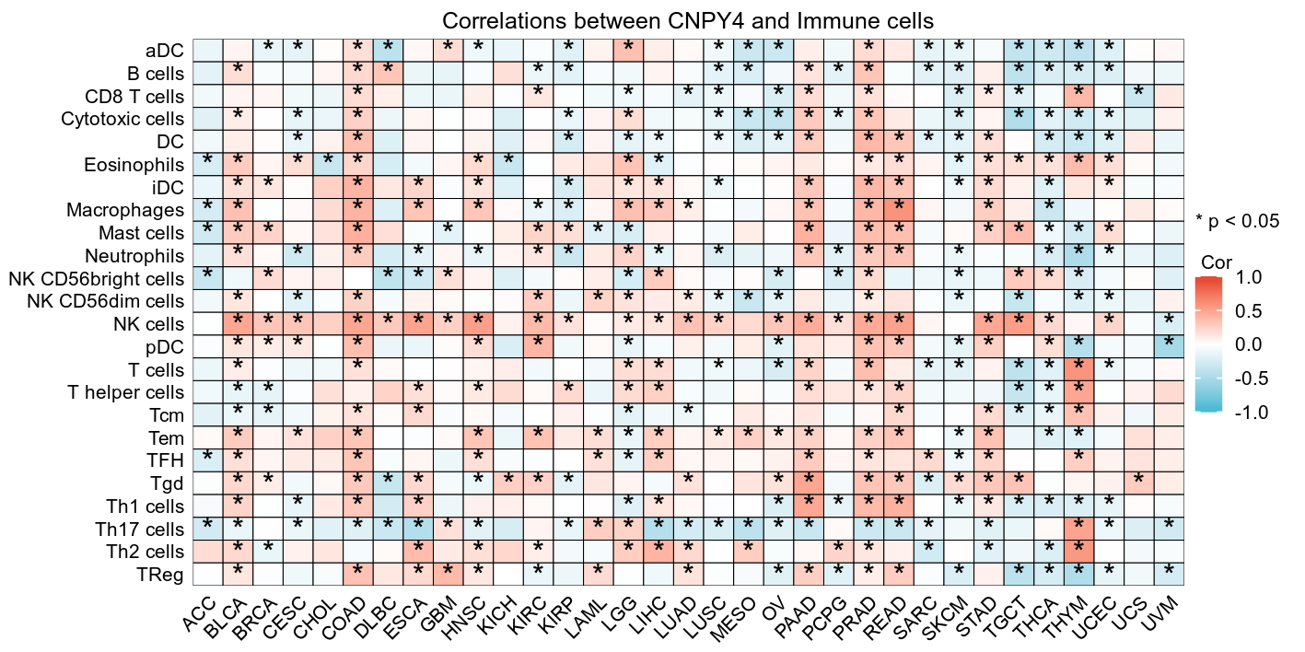

Note: LIHC, liver hepatocellular carcinoma.

