Figure S12. Differential expression analysis of CNPY4 in hepatocellular carcinoma and other cancer types.
(A)

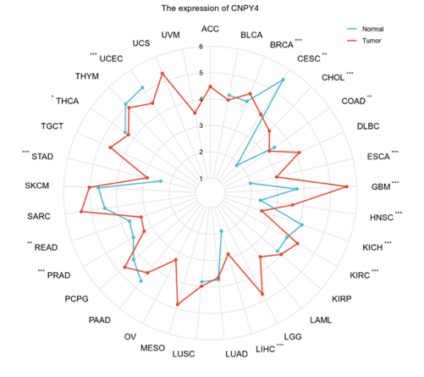
(B)

- Boxplot showing the expression levels of CNPY4 (log₂[TPM + 1]) in tumor (red) and normal (blue) tissues across various cancer types; (2) Radar plot comparing CNPY4 expression levels between tumor and normal tissues. The red line represents tumor tissues, and the blue line represents normal tissues.
Note: LIHC, liver hepatocellular carcinoma; TPM, transcripts per million.

