# Figure S11. Bootstrap ROC curves for the random forest model in the training and validation sets

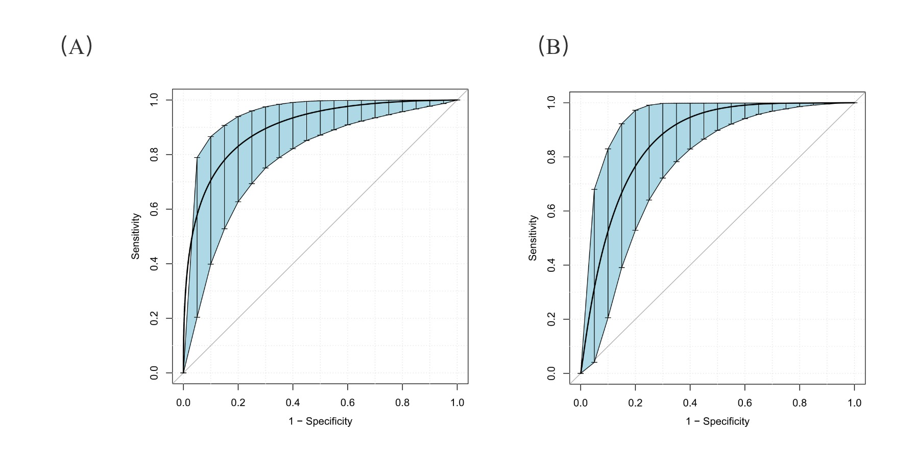

1. Bootstrap ROC curves for the random forest model in the training dataset; (B) Bootstrap ROC curves for the random forest model in the validation dataset.