# Figure S10. Causal relationship between HLA-A (exposure) and serum total protein levels (outcome).

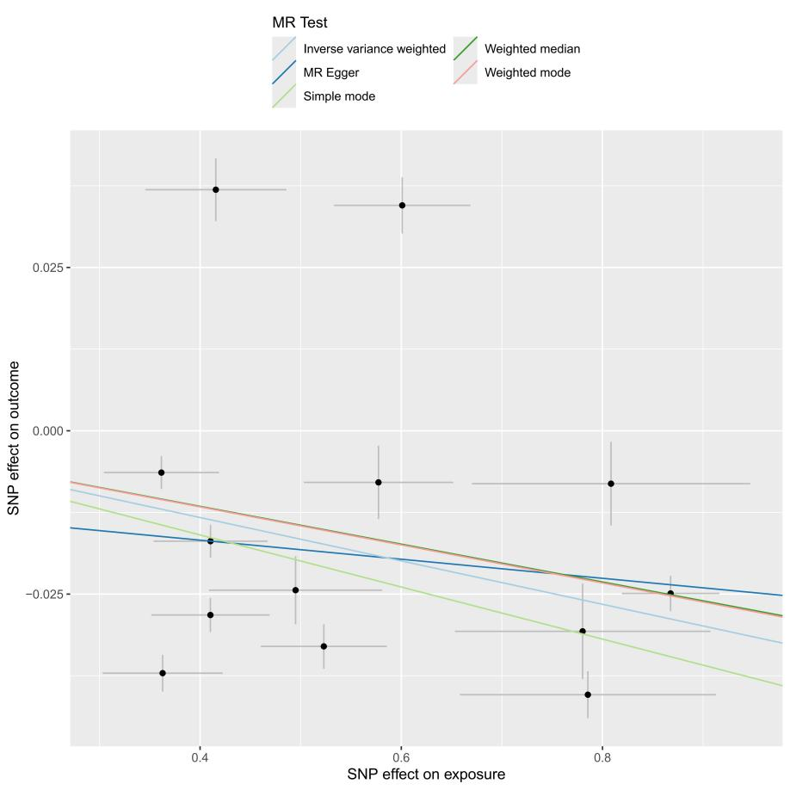

**(B)**

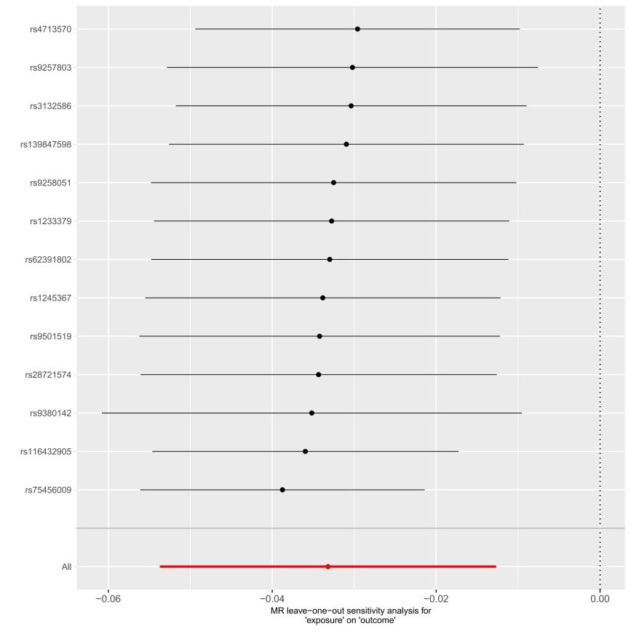

1. scatterplot of the MR analysis; (B) sensitivity analysis