# Figure S8. Scatterplots of MR analysis between IGF-1 (exposure), urinary sodium (exposure) and MASLD (outcome).

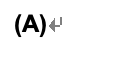

**(B)**

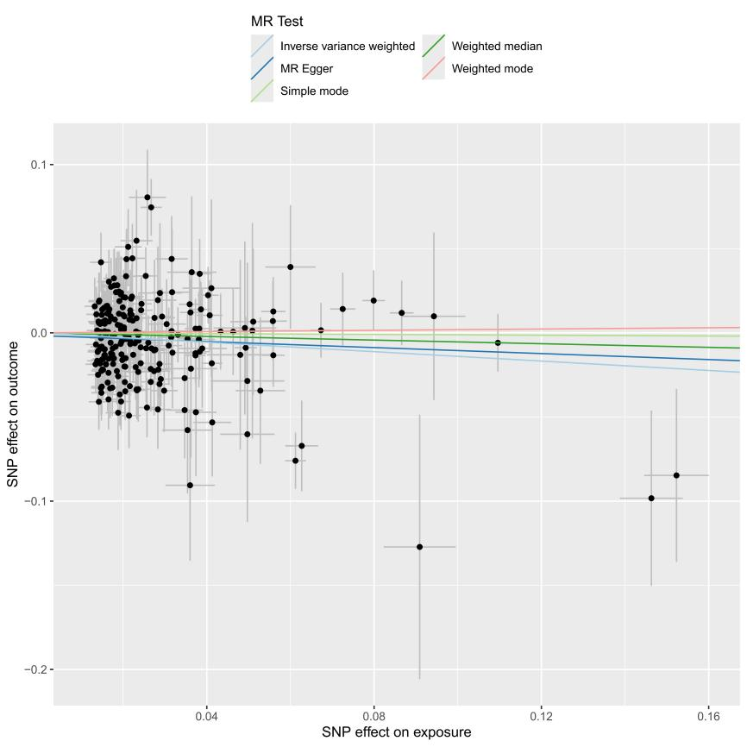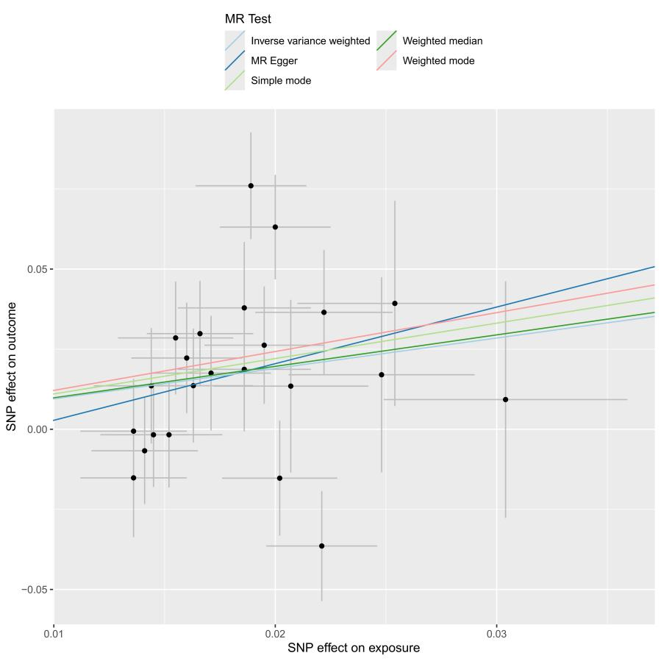

1. IGF-1; (B) urinary sodium