# Figure S7. Scatterplots of MR analysis between albumin (exposure), HDL-C (exposure), and MASLD (outcome).



**(B)**

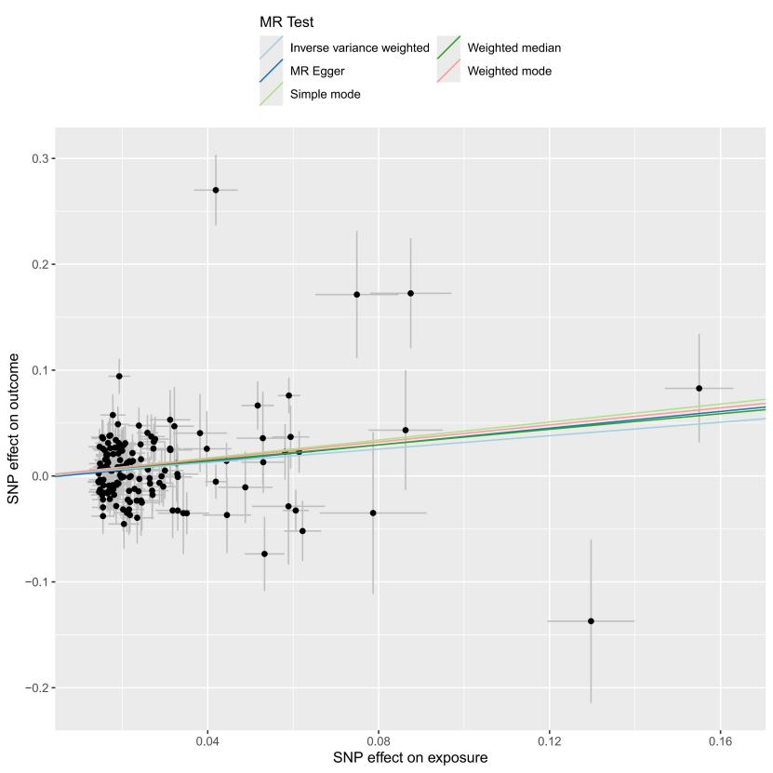

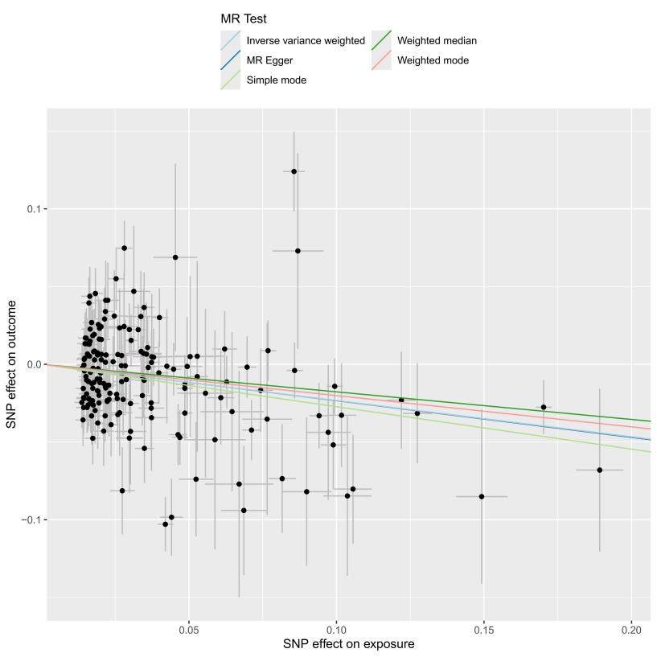

1. albumin; (B) HDL-C