# Figure S6. Scatterplots of MR analysis between Apolipoprotein A (exposure), GGT (exposure), and MASLD (outcome).

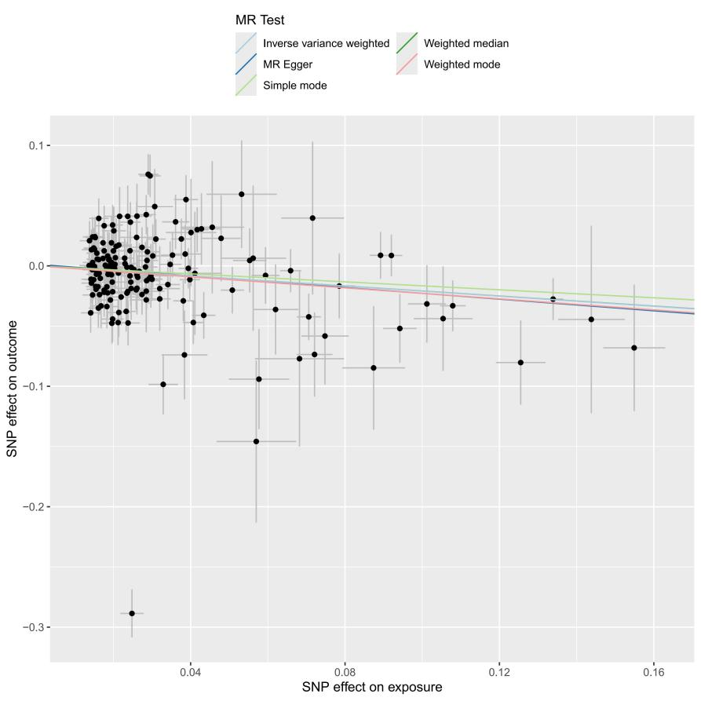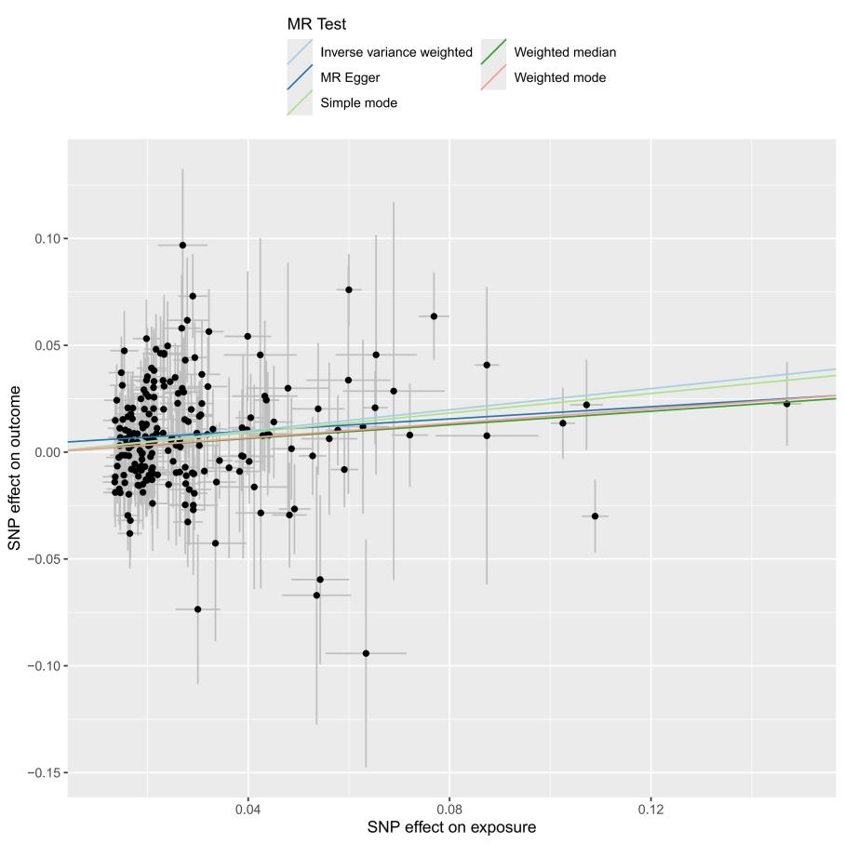

**(B)**

Apolipoprotein A; (B) gamma glutamyltransferase