# Figure S5. Causal relationship between SCG3 (exposure) and MASLD (outcome).

**(B)**

**(A)**

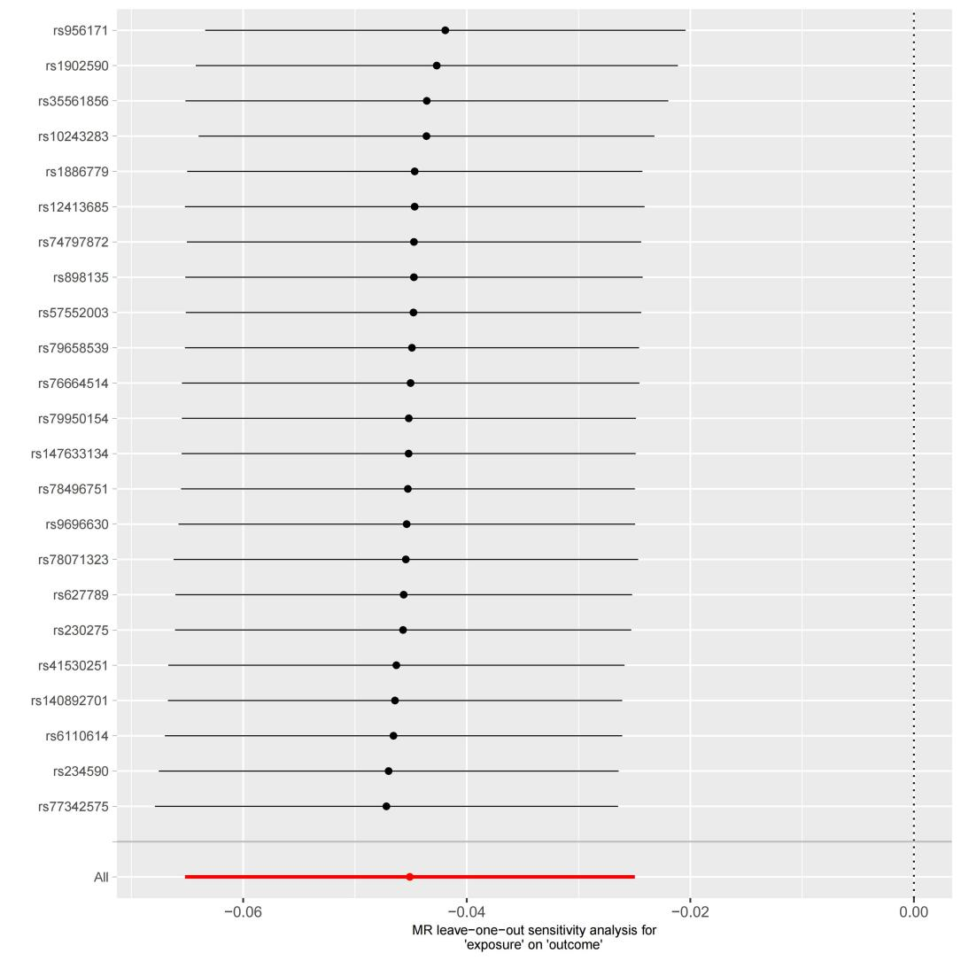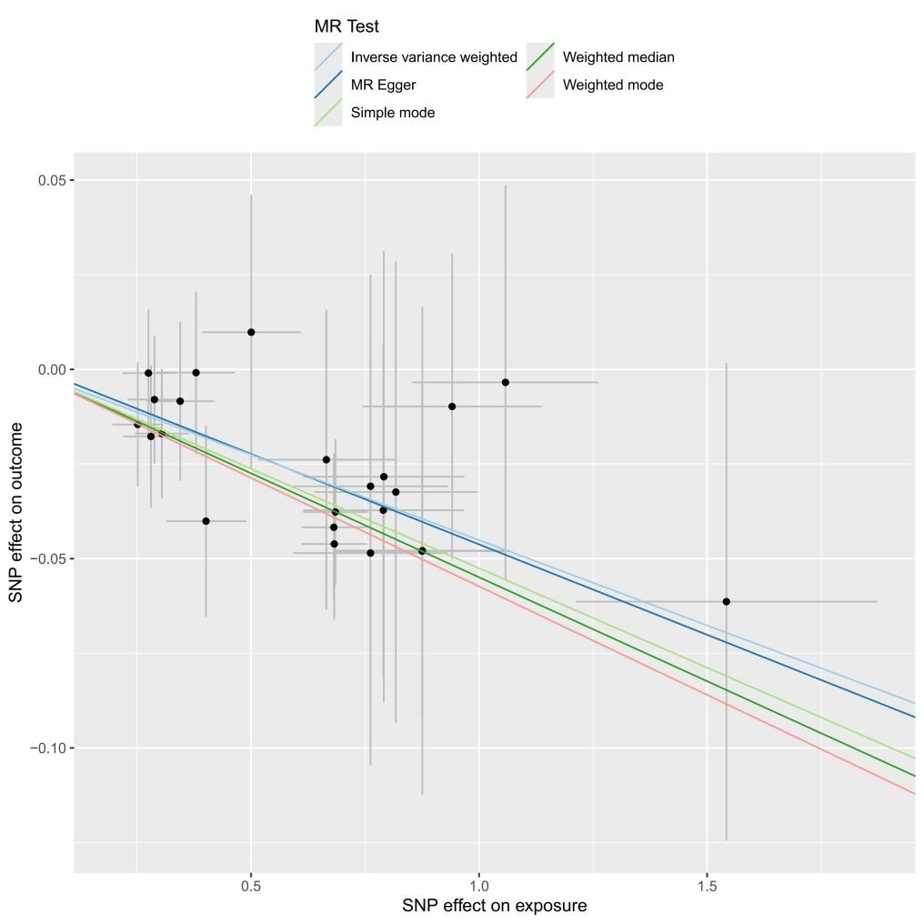

1. scatterplot of the MR analysis; (B) sensitivity analysis