# Figure S4. Causal relationship between HLA-A (exposure) and MASLD (outcome).

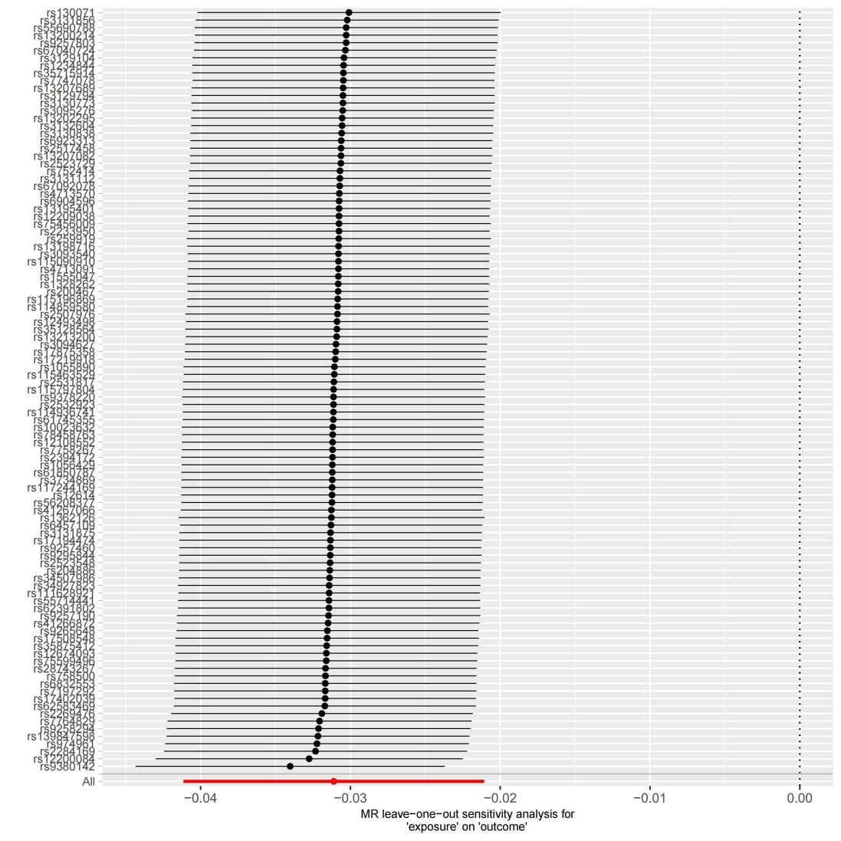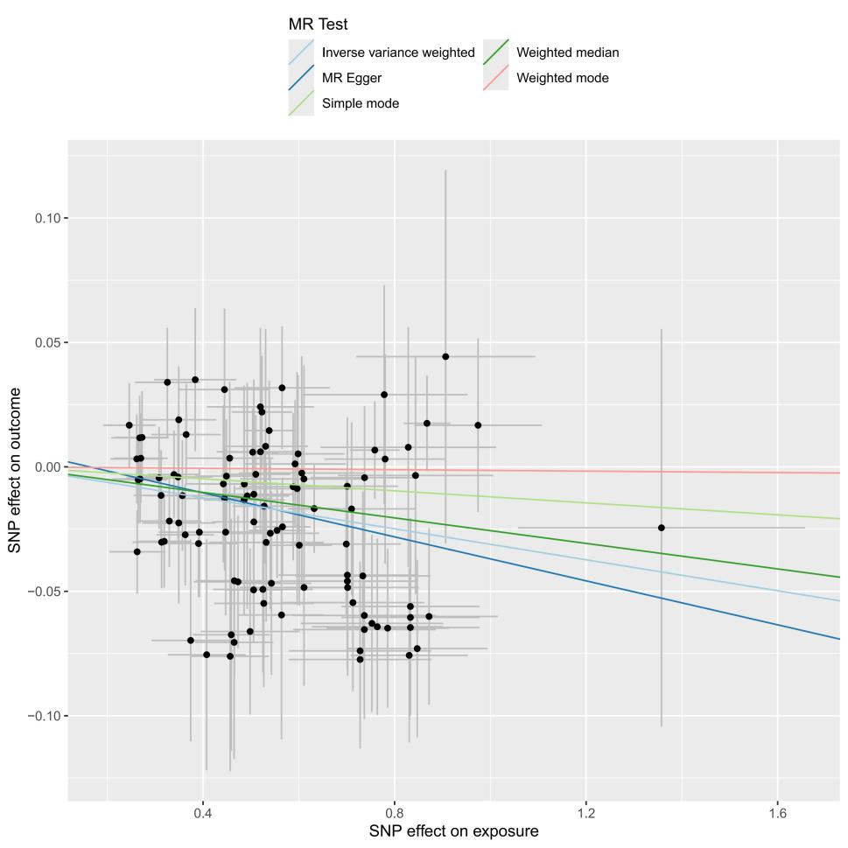

**(A)**

**(B)**

(A) scatterplot of the MR analysis; (B) sensitivity analysis