# Figure S3. Causal relationship between ENTPD6 (exposure) and MASLD (outcome).

**(A)**

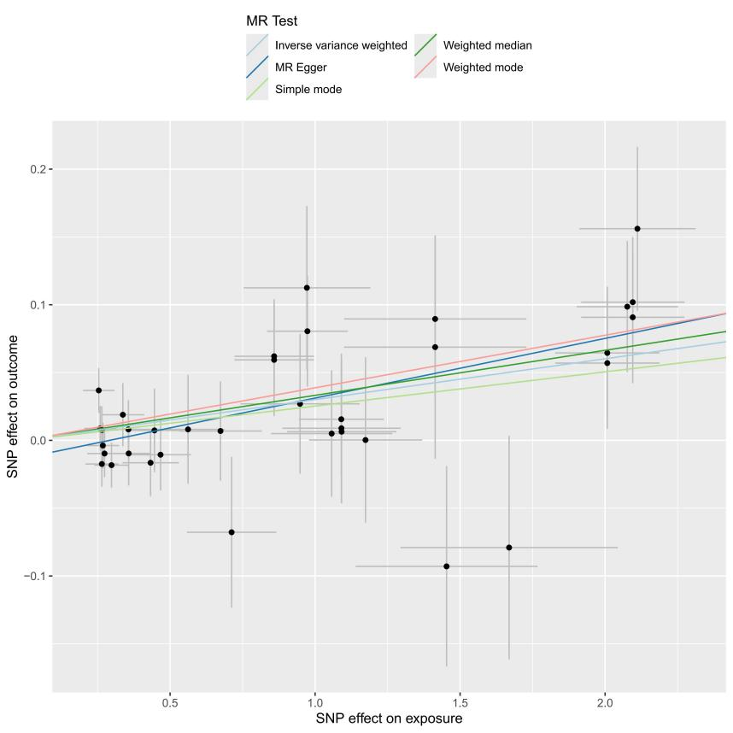

**(B)**

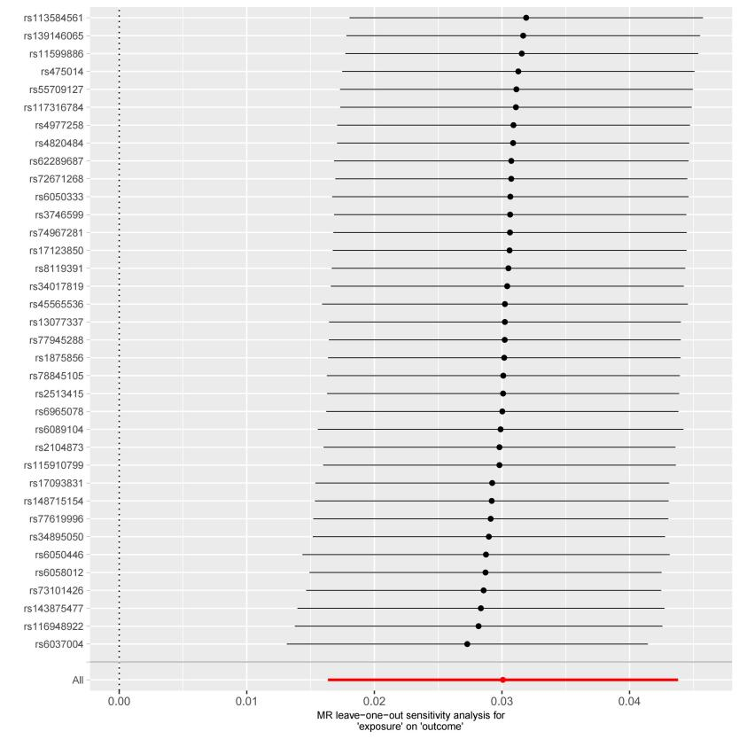

(A) scatterplot of the MR analysis; (B) sensitivity analysis