# Figure S2. Causal relationship between CNPY4 (exposure) and MASLD (outcome).

**(B)**

**(A)**

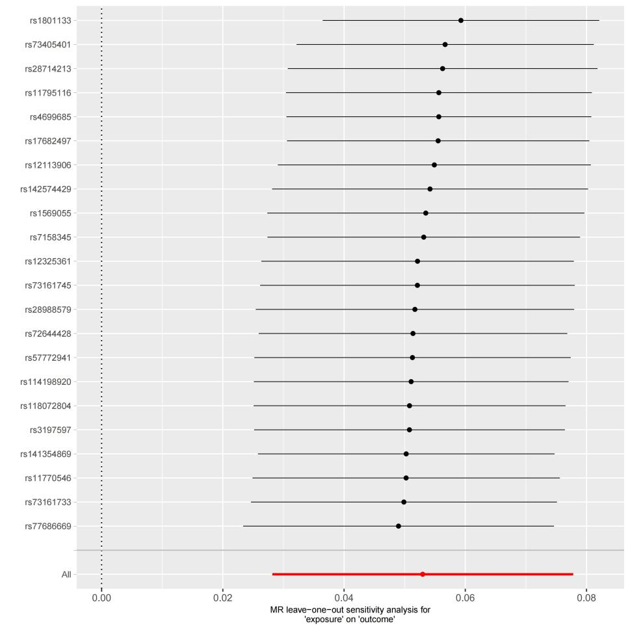

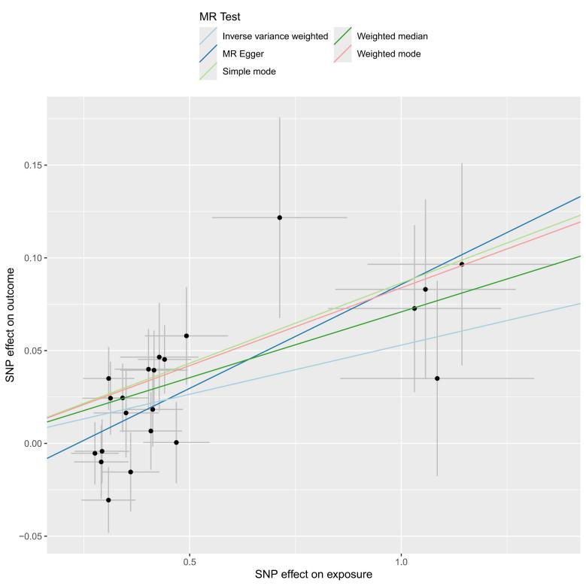

(A) scatterplot of the MR analysis; (B) sensitivity analysis