# Figure S1. Causal relationship between APOE (exposure) and MASLD (outcome).

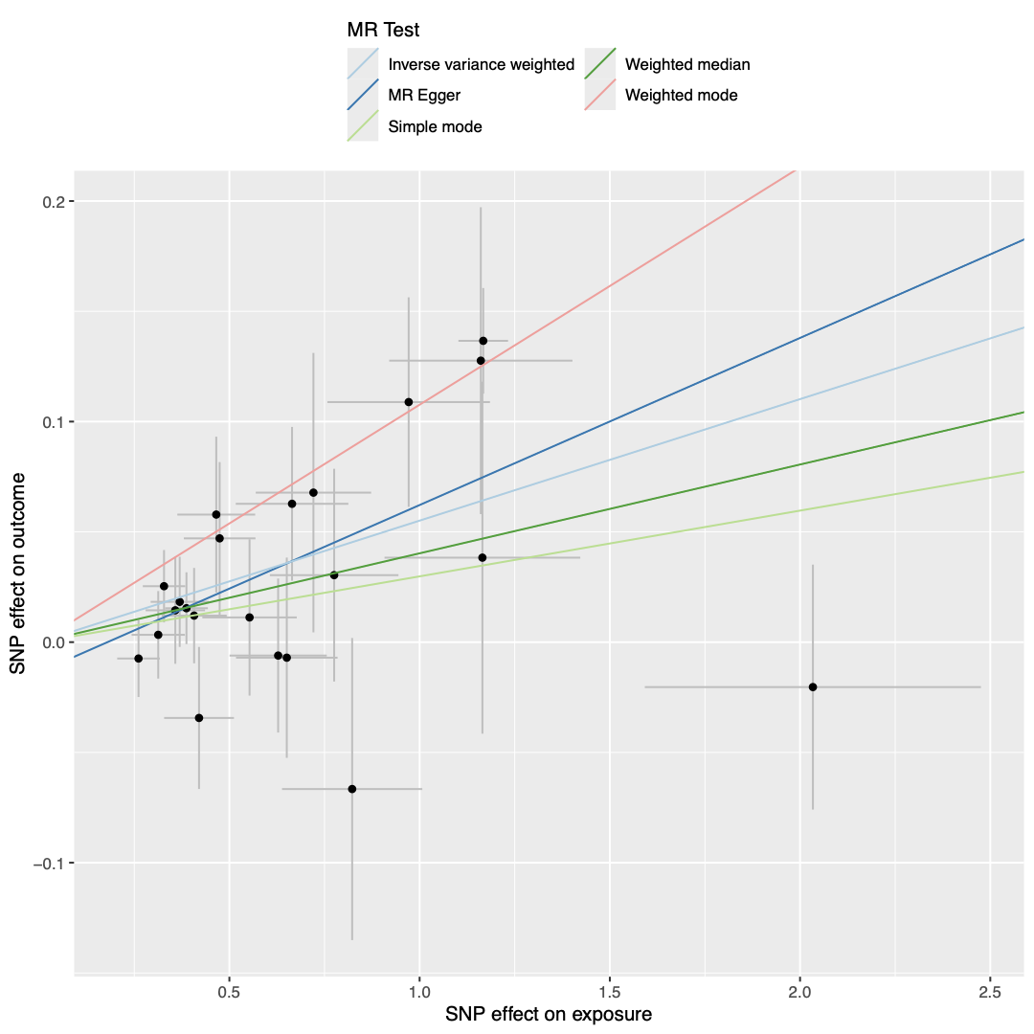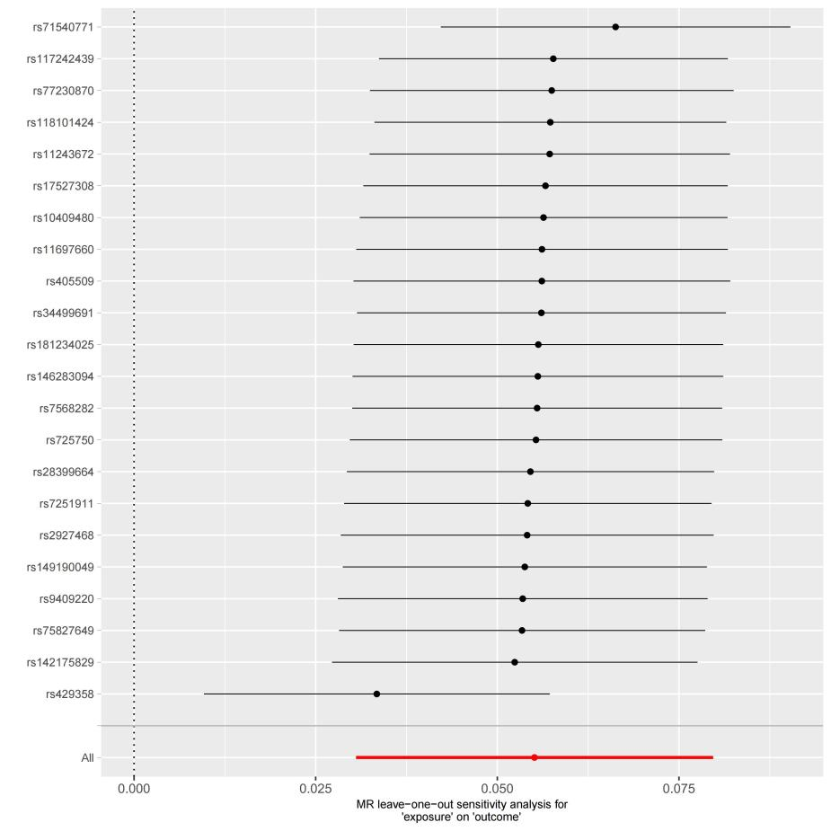

**(B)**

**(A)**

(A) scatterplot of the MR analysis; (B) sensitivity analysis