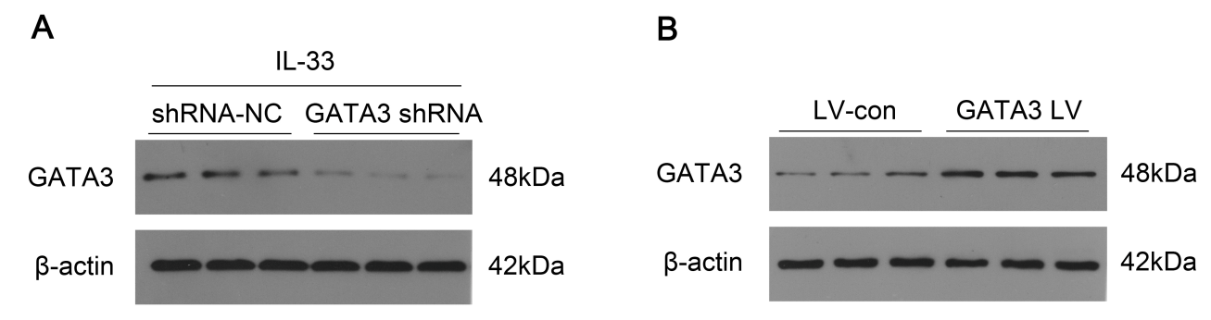
Supplementary Fig. 4. Expression of GATA3 in RAW264.7 cells which were infected with control, GATA3 shRNA (A) or GATA3-overexpressed plasmids (B) were measured by western blot.

