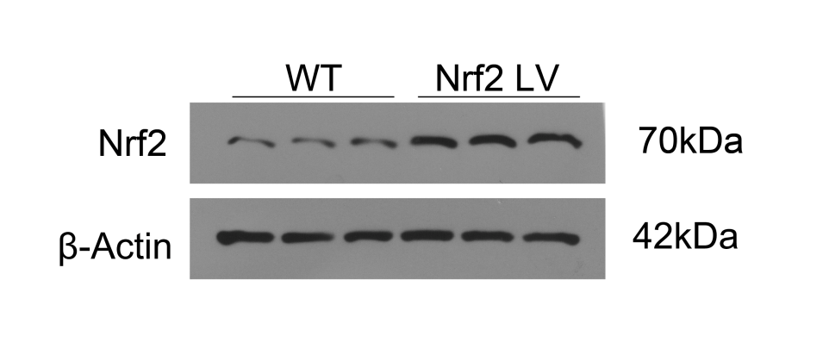
Supplementary Fig. 3. Expression of Nrf2 in HepaRG cells which were infected with control or Nrf2-overexpressed plasmids were measured by western blotting.

