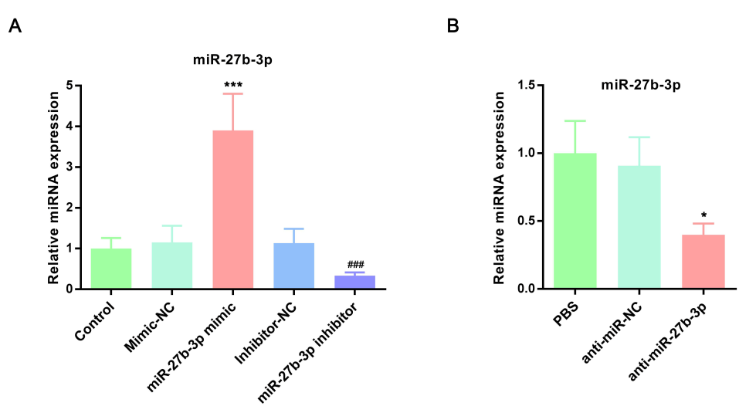
Supplementary Fig. 2. The regulation of miR-27b-3p in vitro and in vivo was confirmed. (A) miR-27b-3p level was determined in primary hepatocytes which were transfected with miR-27b-3p mimic, inhibitor, or miR-NC by qRT-PCR. ***p < 0.001 vs. mimic-NC group. ### p < vs. inhibitor-NC group. (B) miR-27b-3p level was determined in mouse livers which were treated with PBS, anti-miR-NC, or anti-miR-27b-3p by qRT-PCR. * p < 0.05 vs. anti-miR-NC group. Experiments were performed in three times and the results are means ± SDs. miR, micro-RNA; SD, standard deviation.

