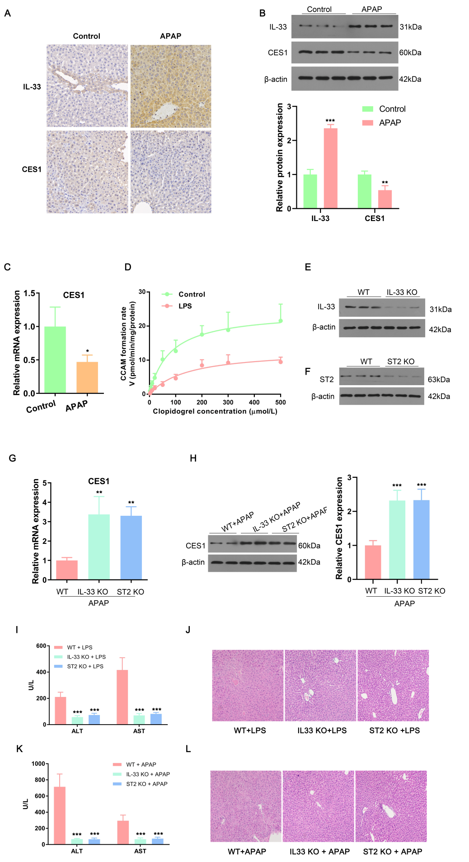
Supplementary Fig. 1. IL-33 downregulates CES1 in APAP-induced liver injury mice. Immunohistochemistry (A) and western blot (B) depict hepatic IL-33 and CES1 expression in control and APAP-induced liver injury mice. (C) CES1 mRNA levels in livers of APAP-stimulated mice were determined by qPCR. (D) Hydrolytic activities of CES1 were evaluated by the hydrolysis of clopidogrel to its metabolite CCAM. (E) The expression of IL-33 in livers of WT or IL-33 knockout mice were measured by western blot. (F) The expression of ST2 in livers of WT or ST2 knockout mice were measured by western blot. Hepatic CES1 mRNA (G) and protein levels (H) were determined in WT, IL-33, or ST2 knockout mice stimulated by APAP. (I) Serum ALT and AST in normal or LPS-stimulated mice were determined by commercial kits. (J) Representative images of HE stained liver tissue of mice treated with vehicle or LPS. (K) Serum ALT and AST in normal or APAP-stimulated mice were determined by commercial kits. (L) Representative images of HE stained liver tissue of mice treated with vehicle or APAP. Experiments were performed in at least triplicate and the results were presented as means ± SDs. *p < 0.05, **p < 0.01, ***p < 0.001 vs. control group or WT group. CES1, carboxylesterase 1; IL, interleukin; APAP, acetaminophen; KO, knockout; ALT, alanine aminotransferase; AST, aspartate aminotransferase; SD, standard deviation.

