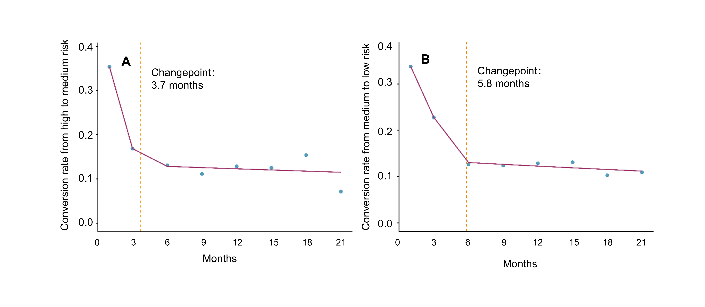
Supplementary Figure 3 Segmented Poisson regression analysis of recovery rates over 24-month follow-up (Pre-Imputation Data)
The segmented Poisson regression plots illustrate the temporal trends in transition rates over the 24-month period. Solid lines represent the fitted models; circles indicate observed recovery rates. Vertical dashed lines mark the automatically estimated joinpoints.
In panel A, the transition rate from high- to medium-risk showed a decline phase from baseline to the joinpoint at 3.7 months (p = 0.003), followed by a plateau phase thereafter. In panel B, the transition rate from medium- to low-risk also displayed two distinct phases: a decline from baseline to the joinpoint at 5.8 months (P = 0.049), after which the trend stabilized.
Follow-up time points (interval starting points) included baseline, 1, 3, 6, 9, 12, 15, 18, and 21 months.

