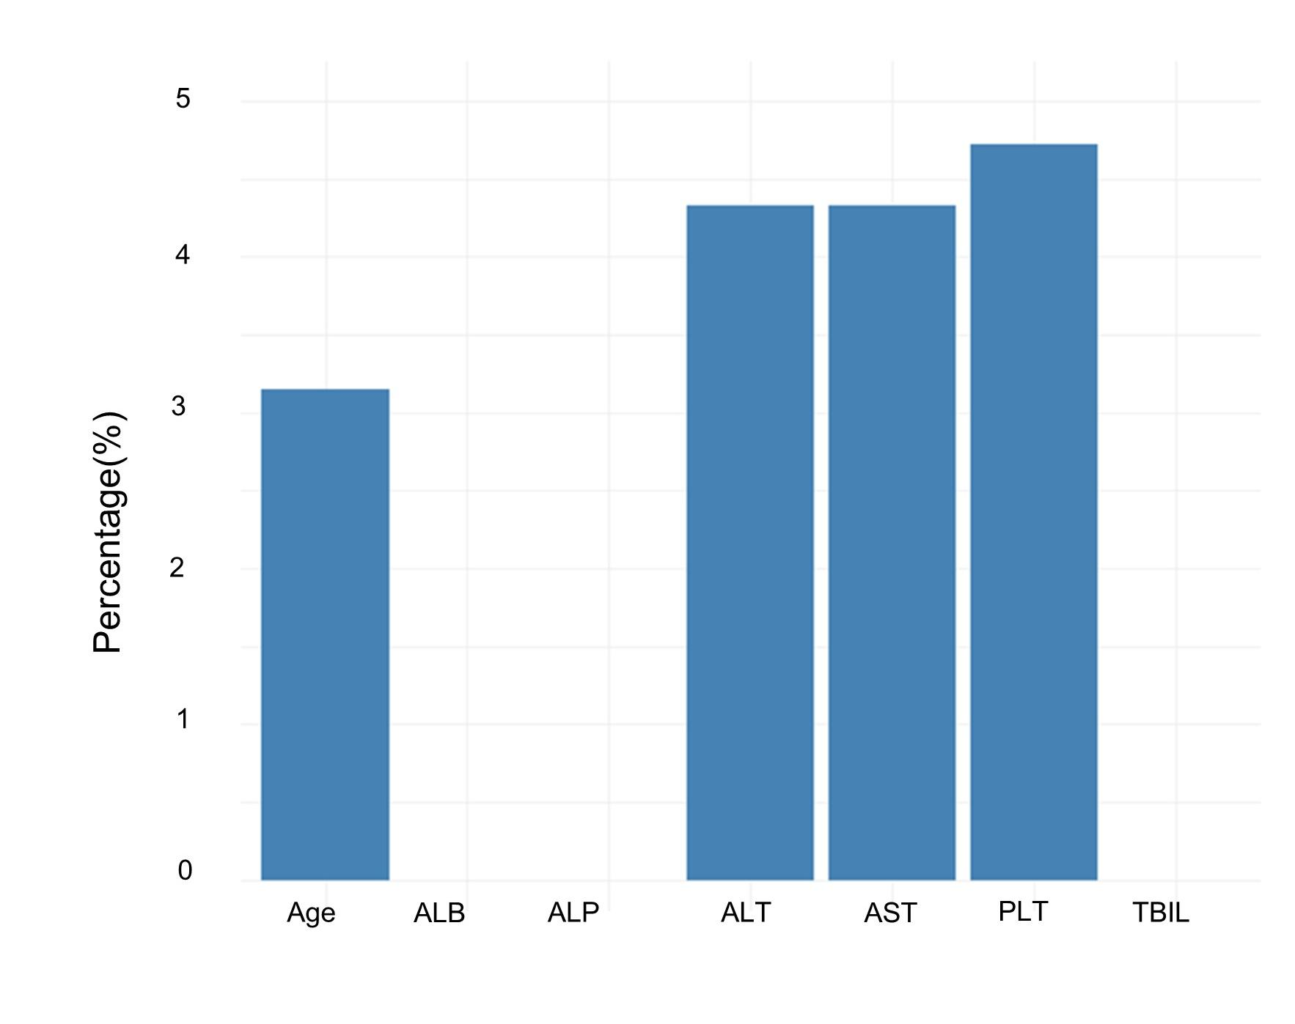
Supplementary Figure 1 Histogram of Missing Data Rates for Covariates in Cox Proportional Hazards Regression Analysis

