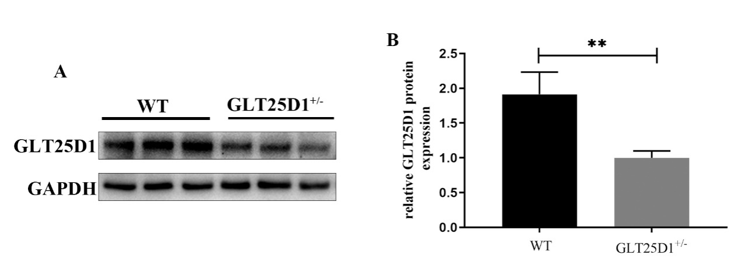
Supplementary Fig 1. The protein level of GLT25D1 in mouse liver from wild type (WT) and heterozygous. A. The protein level of GLT25D1; B. Ratio of target protein gray value to GAPDH gray value.

