Supplemental Table 1. Focused solid tumor assay gene list
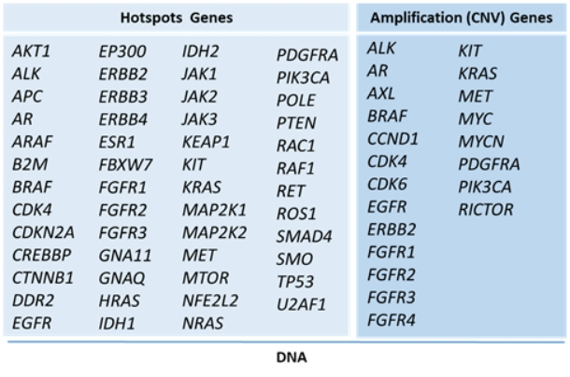
CNV, copy number variation.

