Supplementary Table 5. Summary of eGFR by the Cockcroft-Gault Method (mL/min) by visit (safety analysis set)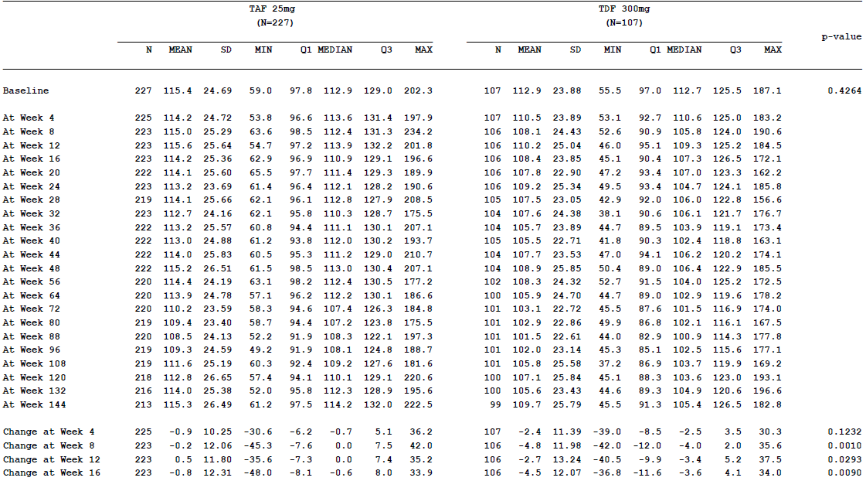

Supplementary Table 5 (continued). Summary of eGFR by the Cockcroft-Gault Method (mL/min) by visit (safety analysis set)

