Supplementary Tables 2A and B. Changes in FibroTest score categories from baseline

Supplementary Table 2A. Study GS-US-320-0110 (HBeAg-positive patients)
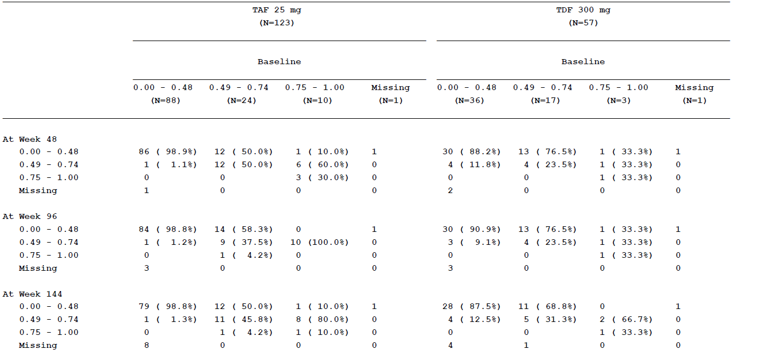

Supplementary Table 2B. Study GS-US-320-0108 (HBeAg-negative patients)
