Supplementary Tables 1A and B. Subject disposition by study
Supplementary Table 1A. Study GS-US-320-0110 (HBeAg-positive patients)
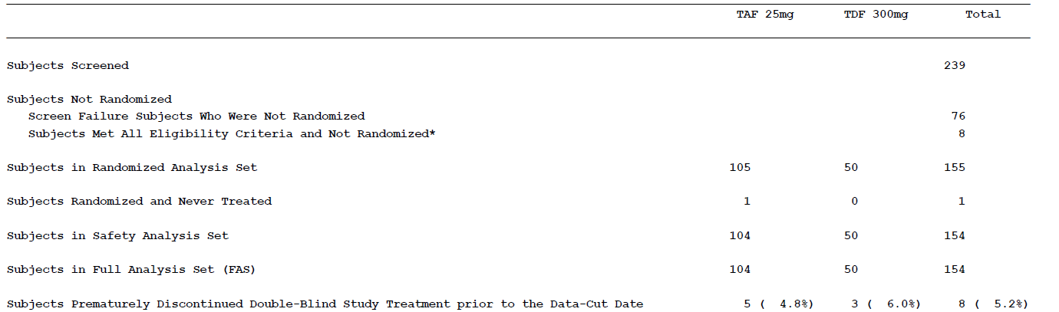
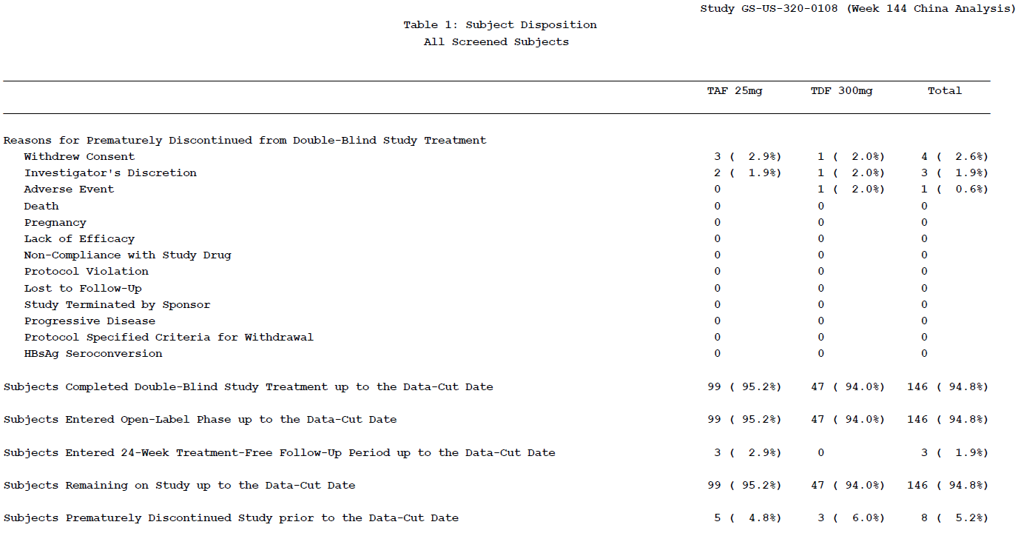
Supplementary Table 1A (Continued). Study GS-US-320-0110 (HBeAg-positive patients)
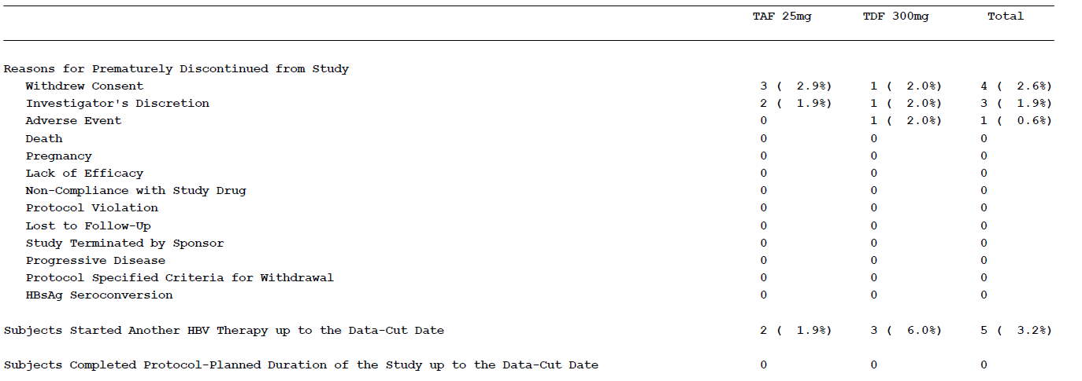

Supplementary Table 1B. Study GS-US-320-0108 (HBeAg-negative patients)
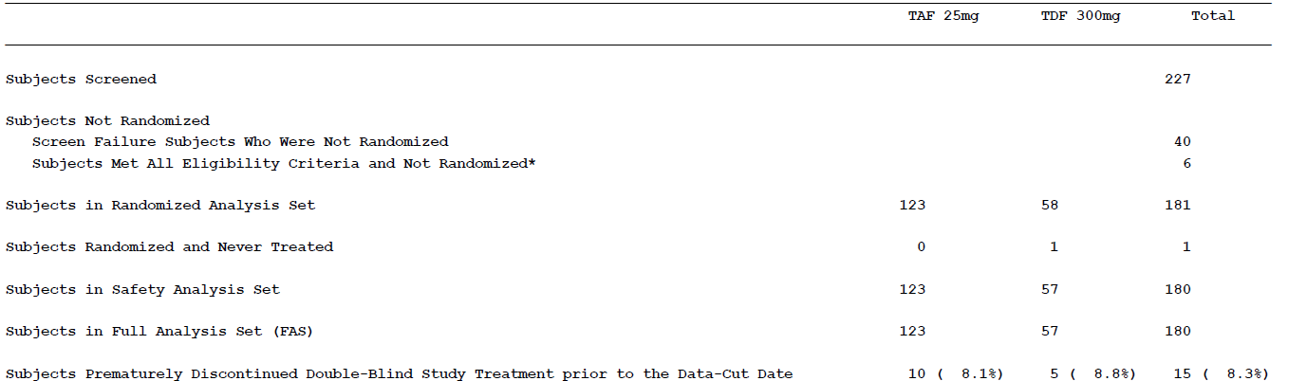
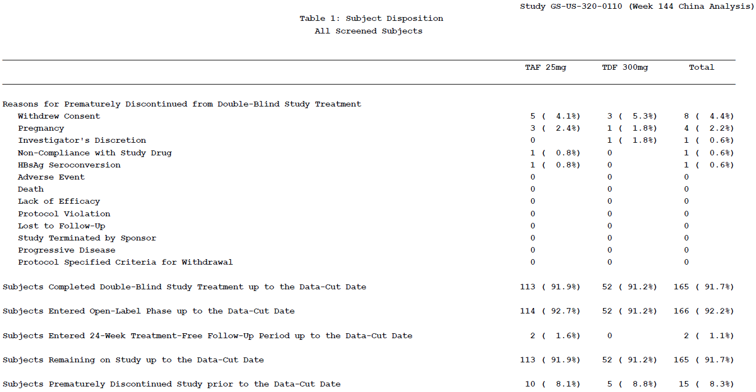

Supplementary Table 1B (Continued). Study GS-US-320-0108 (HBeAg-negative patients)
