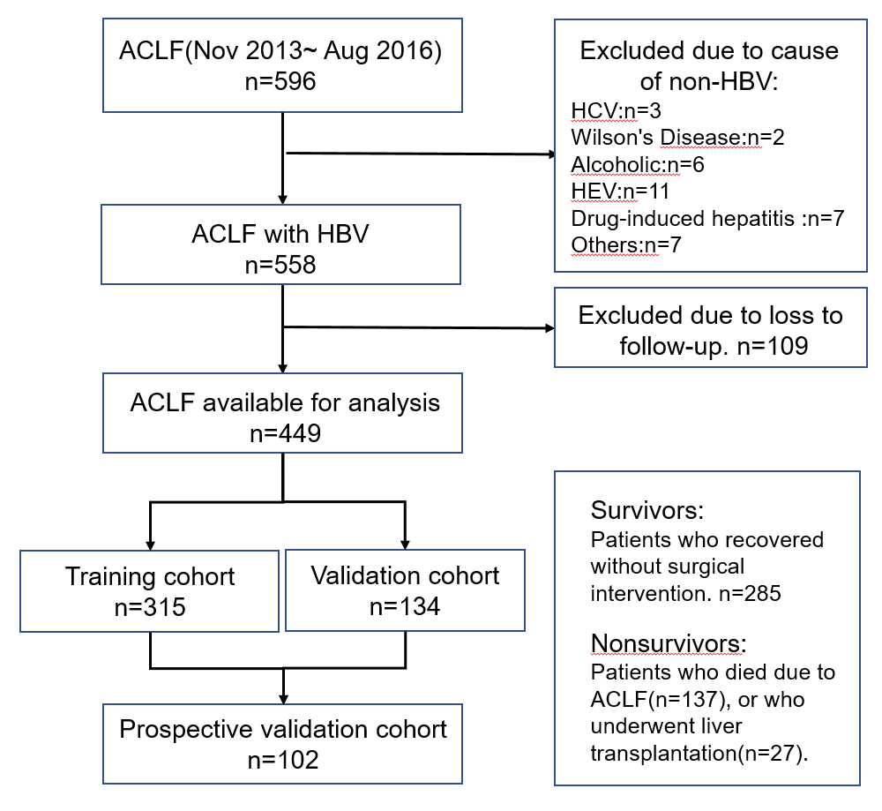

Supplementary Fig. 1. Patient enrollment and study design.

