24h
150

100
2.5

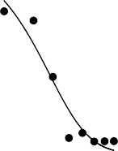2.0
E
GI50= 14.76nM

1.5

1.0
A
MiaPaCa2
****
**** **** **** **** ****
% Viability
Abs 450nm
50
0.5

0 0.0
10-1

100
Dose CuB nM

101

48h

150

100
Dose CuB nM

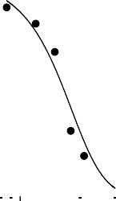4
B
****
****
****
**** **** **** **** ****
M
F
GI50= 39.22 n

3
Abs 450nm

2

50 1
% Viability

0
0 10-1 100 101
Dose CuB nM

72h

150

100
% Viability

50
Dose CuB nM
4G
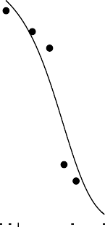3 GI50= 35.21 nM
Abs 450nm

2

1

0 0
C
**** ****
****
**** **** **** **** ****
10-1 100 101
Dose CuB nM

96h
150 5

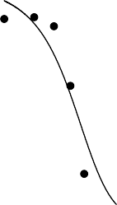4
D
Dose CuB nM
****
**** **** **** ****
****
H
GI50= 66.69 nM
100
Abs 450nm
3

2
% Viability
50
1

0 0
10-1

100
Dose CuB nM

101

Dose CuB nM
Supplementary Figure 5 Viability of MiaPaCa2 cells treated with Cucurbitacin B (CuB) ranging from 0-1000 nM and Gemcitabine 50nM as determined by CCK8 colourimetric assay MiaPaCa2 cells treated with CuB for A: 24 hours, B: 48 hours, C: 72 hours, D: 96 hours. GI50 values of MiaPaCa2 cells E: 14.76 nM for 24 hours F: 39.22 nM for 48 hours G: 35.21 nM for 72 hours and H: 66.69 nM for 96 hours. Significance between treatment groups and the negative control calculated using one-way ANOVA represented over treatment columns by ‘*’ = p<0.05, ‘**’ = p<0.01, ‘***’ = p<0.005, ‘****’ = p<0.001.

