**Supplementary Table 5**. Molecular docking results of BA and E2F1

|  |  |  |  |  |  |
| --- | --- | --- | --- | --- | --- |
| Target protein | Compound | Molecular structure | Binding energy score | Interaction mode | |
| E2F1 | BA |  | -6.07 kcal/mol | | π-π interactions  hydrogen bonding  hydrophobic interactions | |

Notes: binding energy function1:

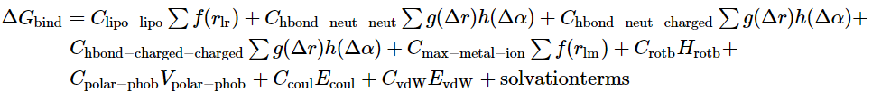

1. Friesner RA, Banks JL, Murphy RB, Halgren TA, Klicic JJ, Mainz DT, *et al*. Glide: a new approach for rapid, accurate docking and scoring. 1. Method and assessment of docking accuracy. J Med Chem 2004;47(7):1739-1749. doi: 10.1021/jm0306430. PMID: 15027865.