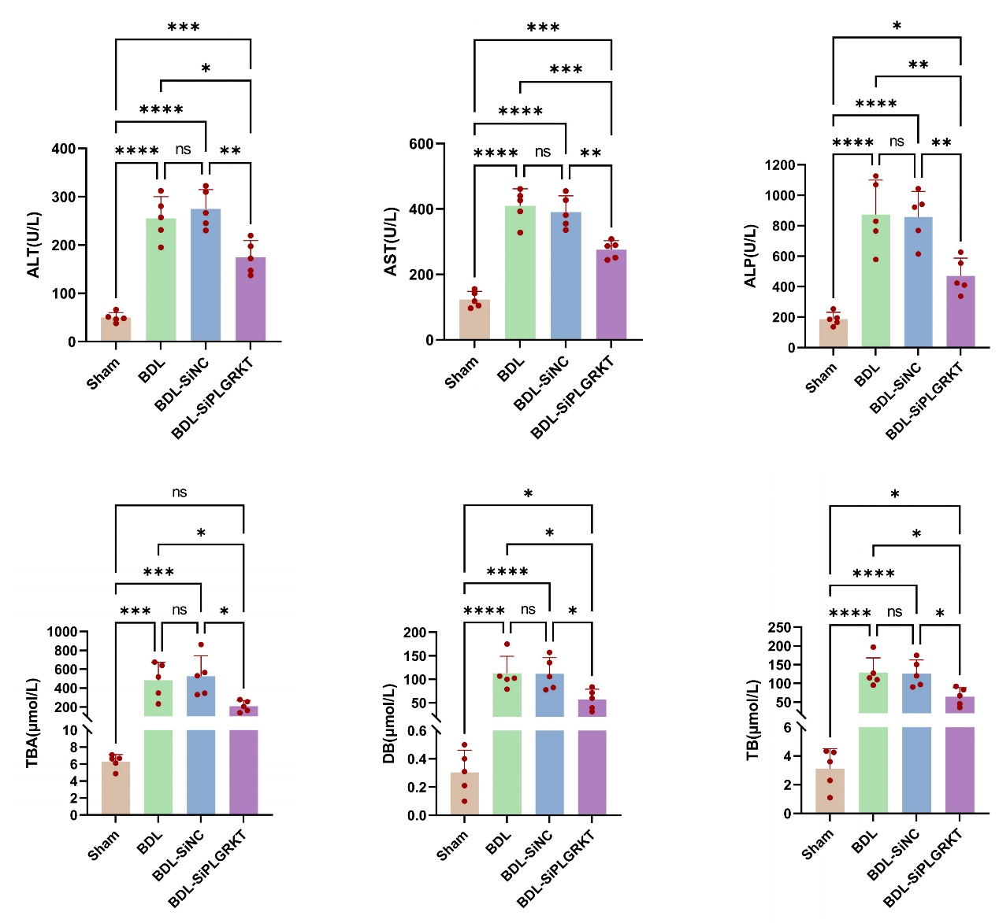
Supplementary Fig. 9. Liver function tests in the four experimental groups of mice. *p<0.05, **p<0.01, ***p<0.001.

