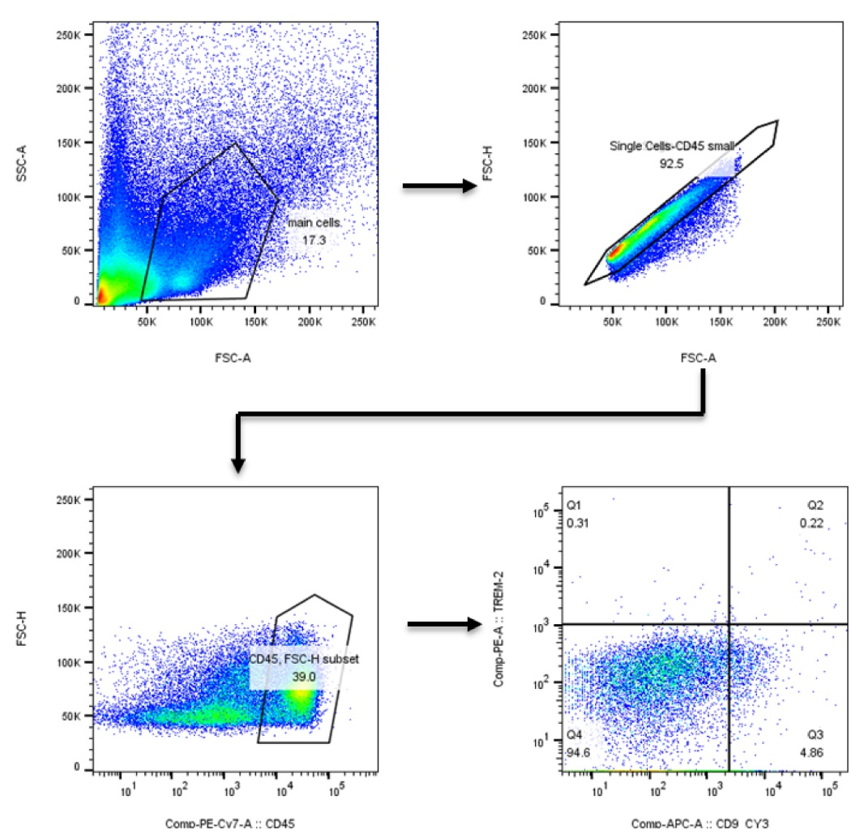
Supplementary Fig. 8. Flow cytometry analysis. Gating strategy for non-parenchymal cells (NPCs) associated with Figure 6D. SAMs were identified as CD45⁺ single cells.

