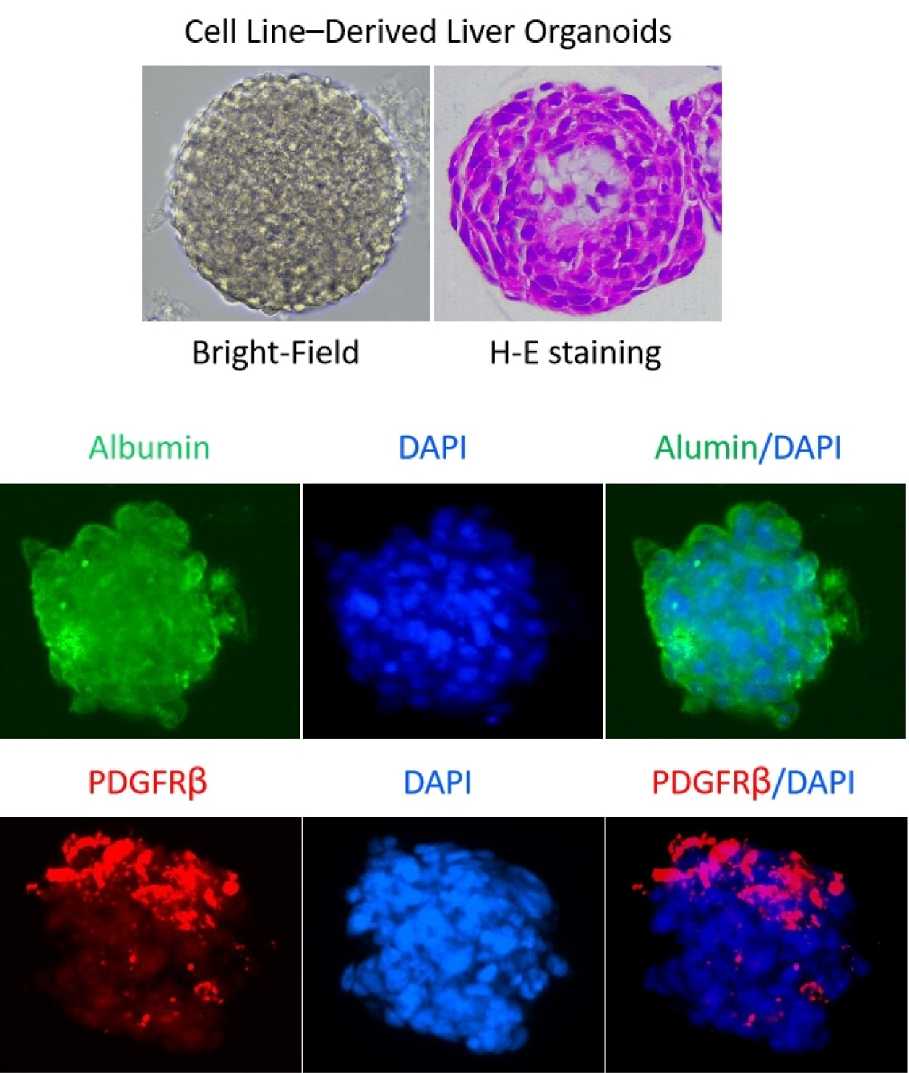
Supplementary Fig. 6. Representative images depicting the construction and characterization of liver organoids. H&E staining illustrates the overall morphology, while immunofluorescence analysis demonstrates the successful expression of the hepatocyte-specific marker Albumin and the stellate cell marker PDGFRβ (from LX-2 cells) within the generated organoids.

