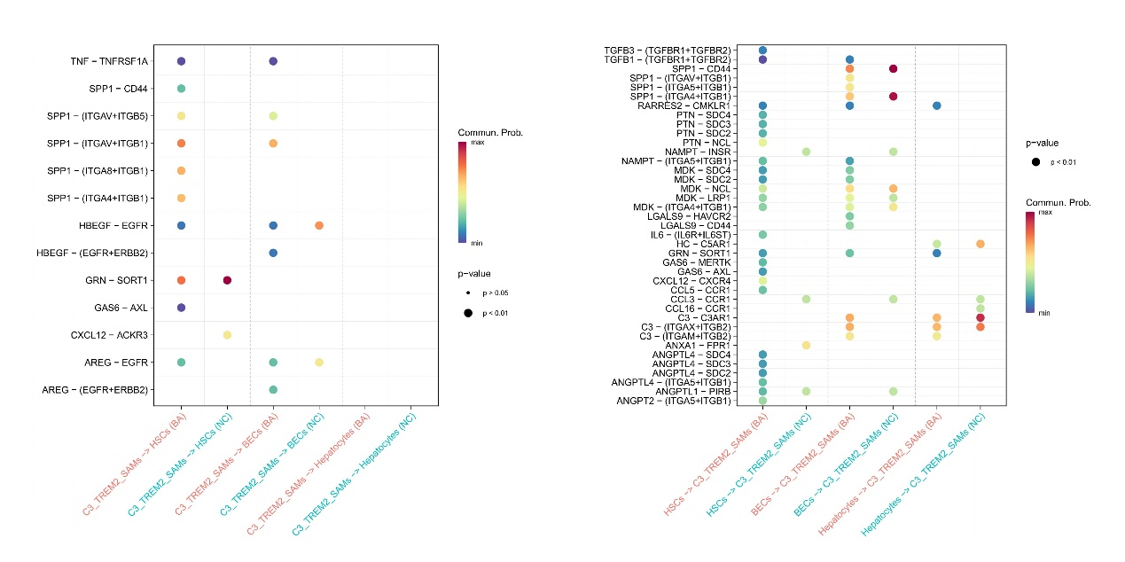
Supplementary Fig. 5. Dot plot of intercellular interactions between scar associated macrophages and hepatic stellate cells between BA and NC.

