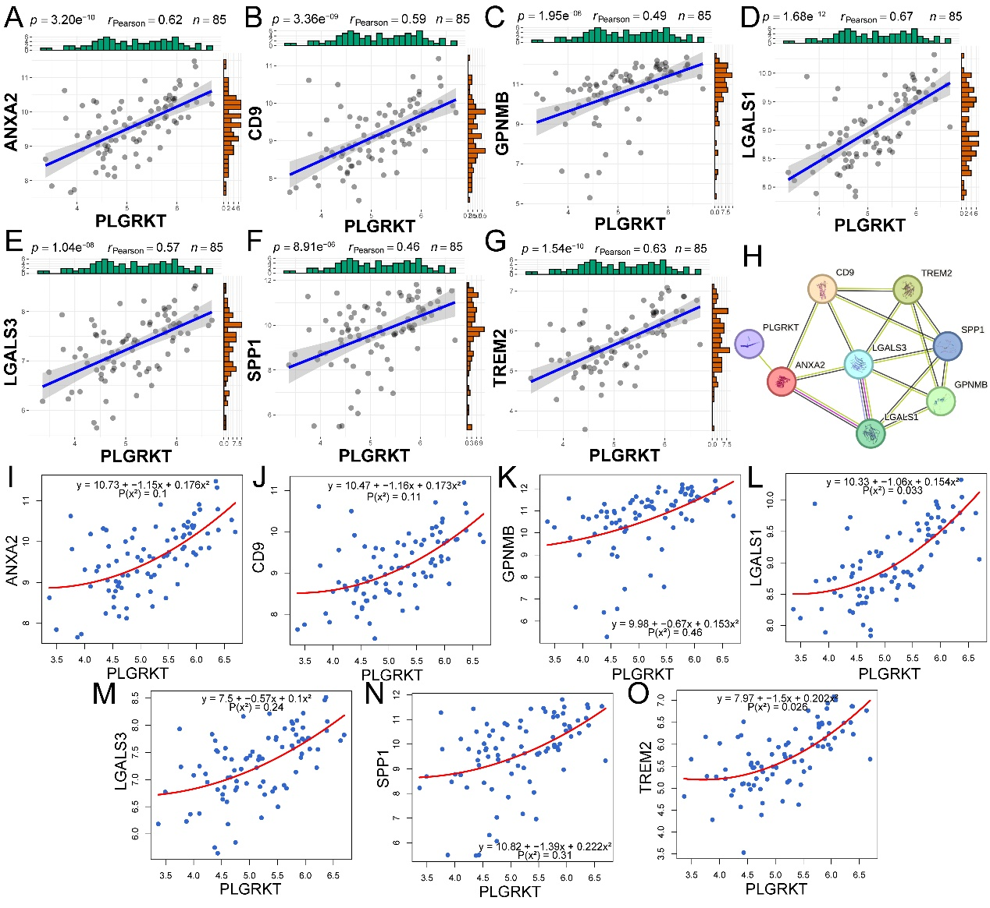
Supplementary Fig. 2. Correlation analysis of PLGRKT and ANXA2, CD9, GPNMB, LGALS1, LGALS3, SPP1 and TREM2 in GSE46960.

