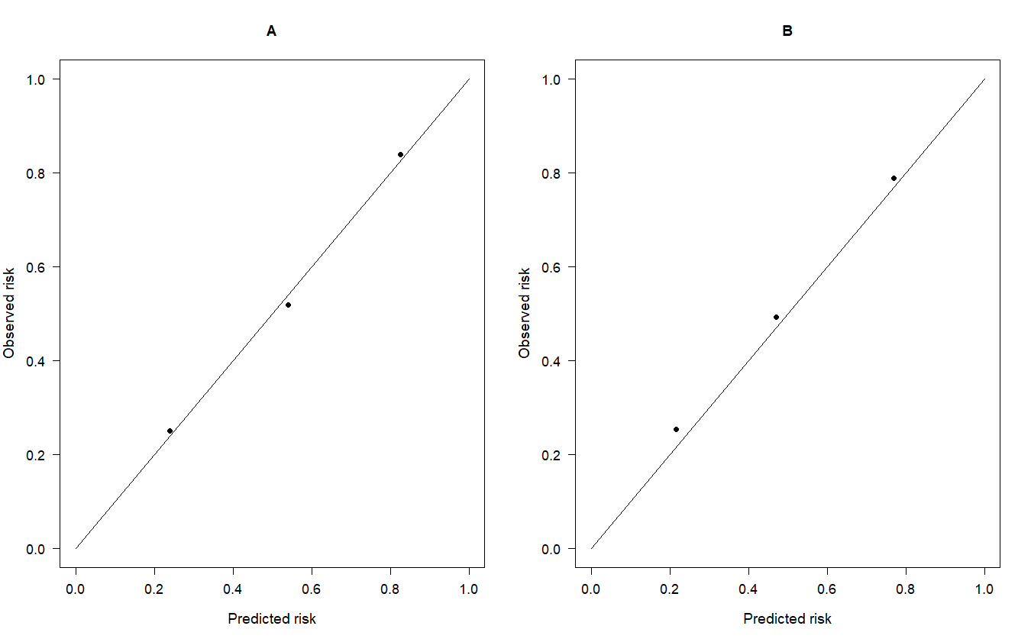
Supplementary Fig. 3. Calibration curves for predicting fatty liver. (A) In the development and the (B) validation cohorts. Y-axis, actual fatty liver probability; X-axis, predicted fatty liver risk; black diagonal line, reference line (ideal nomogram).

