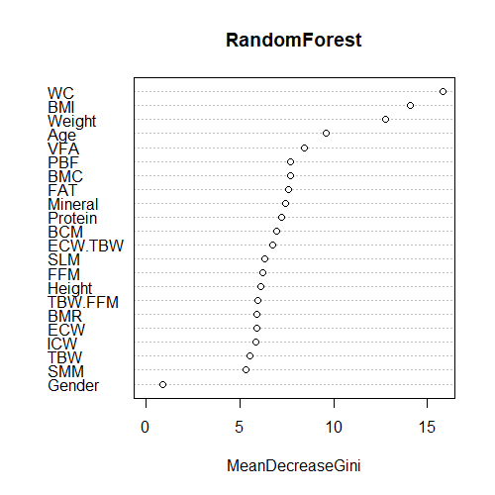
Supplementary Fig. 2. Random forest plot of variables with the greatest importance. BCM, body cell mass; BMC, bone mineral content; BMI, body mass index; BMR, basal metabolic rate. ECW, extracellular water; FFM, fat-free mass; ICW, intracellular water; PBF, percent body fat; SLM, soft lean mass; SMM, skeletal muscle mass; TBW, total body water; VFA, visceral fat area; WC, waist circumference.

