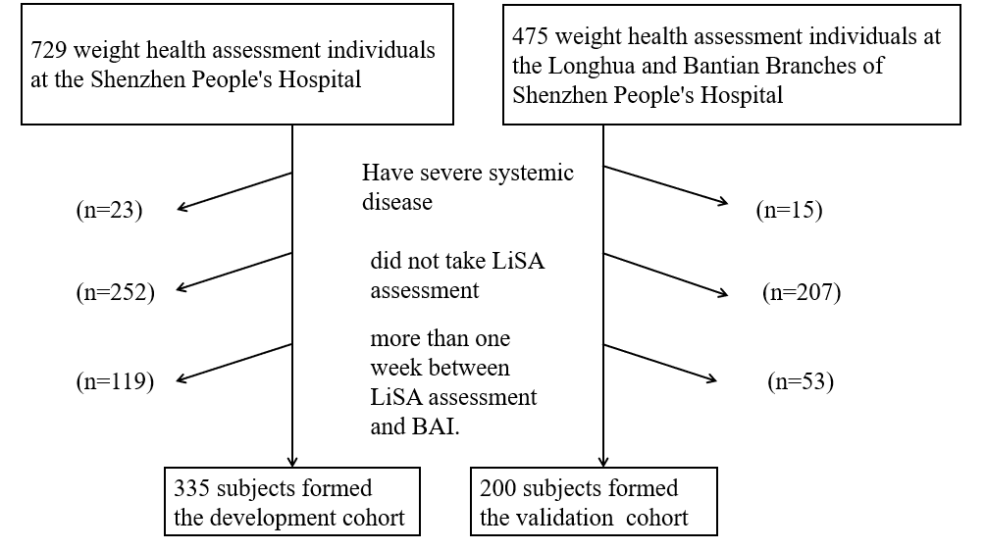
Supplementary Fig. 1. CONSORT diagram for the development and validation cohorts, showing subjects assessed (September 2020 to June 2021), eliminated, and selected for inclusion.

