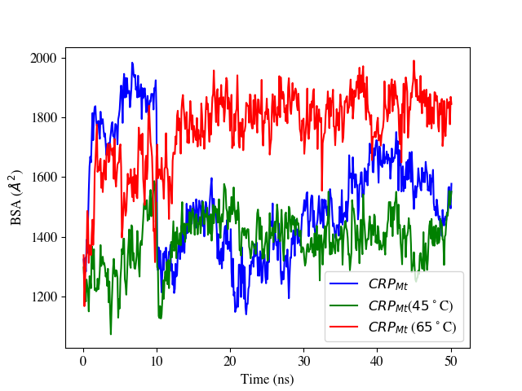
Figure S7. Change in buried surface area (BSA) over simulation time for CRP_{Mt} at normal conditions or control (at 25 °C) versus higher temperature. BSA increases from 1325 (at the starting point) to 1578 Å² (end of simulation) for the protein dimer at native conditions (control at 25 °C in water). BSA increases from 1298 to 1552 Å² for the protein dimer at 45 °C and 1339 to 1845 Å² at 65 °C.

