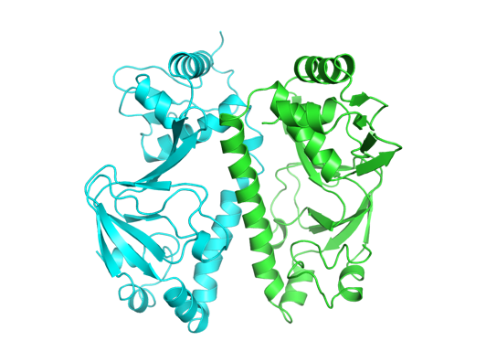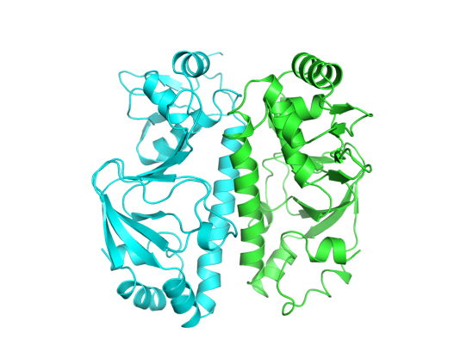
25 ns, 24.3 Å
50 ns, 23. 4 Å

0 ns, 24.2 Å

Figure S6. Snapshots of CRP_{Mt} at 25 °C. The two chains are shown in green and cyan cartoons. The starting structure is taken from the control simulation, showing the changes in the overall structures during the simulation. The radius of gyration (Rg) in Å is provided along with the time stamp.

