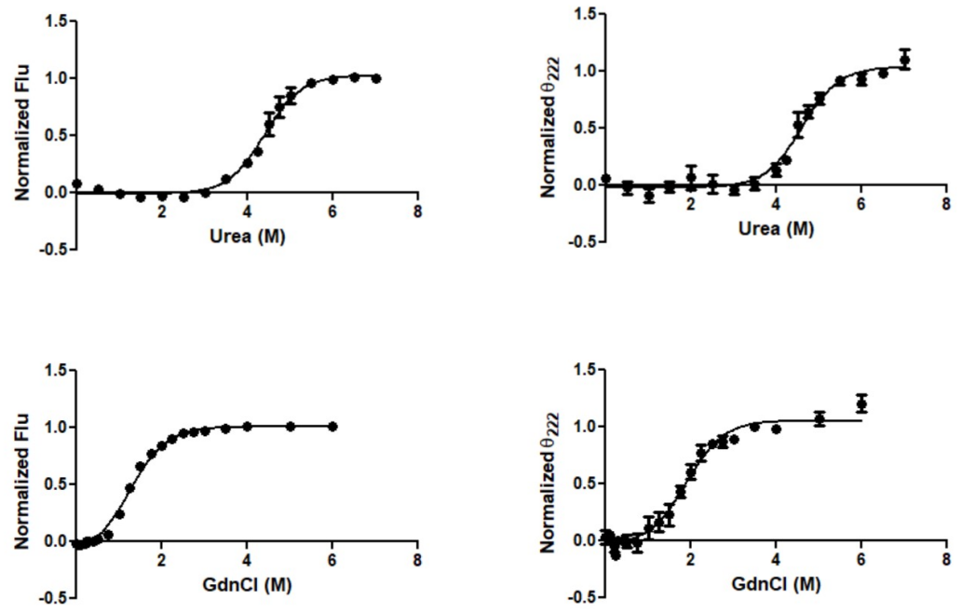
Figure S3: Urea and GdnHCl mediated equilibrium unfolding of CRPMt in presence of c-AMP measured by fluorescence and circular dichroism. For fluorescence experiments, intrinsic Trp fluorescence intensity values (Flu) at 334 nm were determined from the fluorescence spectra, normalized (as above), and plotted against increasing urea (top) and GdnHCl (bottom) concentration. From the images, it was evident that the protein was more resistant towards urea compared to GdnHCl. For CD, The θ₂₂₂ (ellipticity at 222 nm) values, derived from the recorded far-UV CD spectra of a CRPMt in the presence of urea (top), and GdnHCl (bottom) were normalized with respect to that of the same protein in the absence of any chemical denaturant. The plots of normalized θ₂₂₂ values vs. urea and GdnHCl concentrations indicate the alternation of secondary structure (particularly α-helix) of the protein samples at increasing urea and GdnHCl concentrations.

