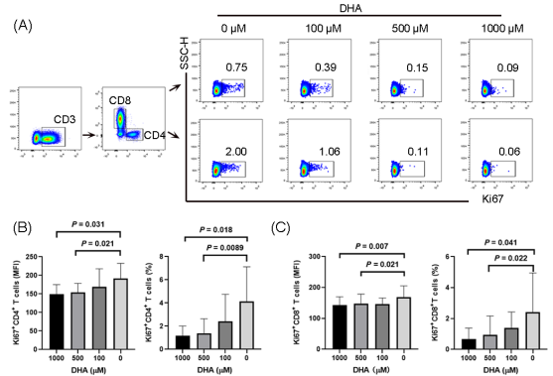

**Figure S8. DHA inhibits T cell proliferation *in vitro* in INRs.**

PBMCs from INRs were separated and cultured in medium with PHA (5 μg/mL) and with/without DHA (0 μM, 100 μM, 500 μM, 1000 μM). Ki67 expression in CD4+ and CD8+ T cells were measured by flow cytometry. (A) Typical flow cytometry chart for Ki67 expression analysis. The expression of Ki67 (MFI or frequency) in CD4+ T cells (B) and CD8+ T cells (C) were obviously decreased after DHA treatment (500 μM, 1000 μM).