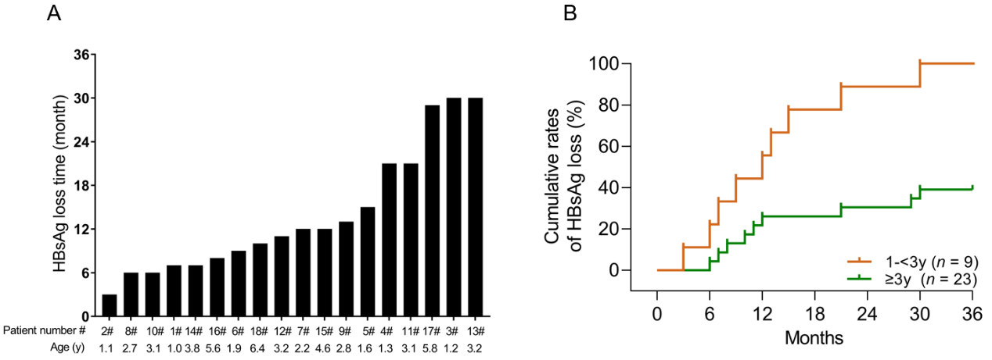
Supplementary Fig. 3. Distribution of serum HBsAg loss time in (A) the cured group and (B) cumulative rate of serum HBsAg loss inpatients 1-3 vs. 3-14 years of age. As shown in (A), 11 children showed HBsAg loss within 12 months. Six children (P1, P2, P8, P10, P14 and P16) showed HBsAg loss around 6 months after antiviral treatment initiation. Nine children under 3 years of age were cured (B, orange line) and another nine of the 23 patients 3-14 years of age were also cured (B, green line).

