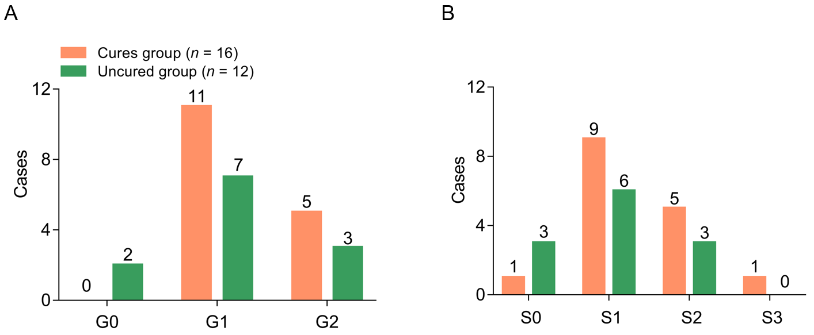

Supplementary Fig. 2. Analysis of baseline liver inflammation grades (A) and fibrosis stages (B) between the cured and uncured groups (marked as orange and green lines, respectively) of CHB children on antiviral treatment. Whether hepatic inflammation favors HBeAg seroconversion is an interesting issue to consider in this study, but it is difficult to draw any clear conclusions because the majority of CHB children had mild or low degrees of active hepatic inflammation and fibrosis. In brief, HBsAg loss was achieved in 61.54% (n = 16) of 26 children with G1 or G2 inflammation. Only two patients with inflammation grade G0 were in the uncured group. All patients had ALT levels lower than 60 U/L. There were some cases of G0 and S0 inflammation and fibrosis, respectively, as shown in Table 1.

