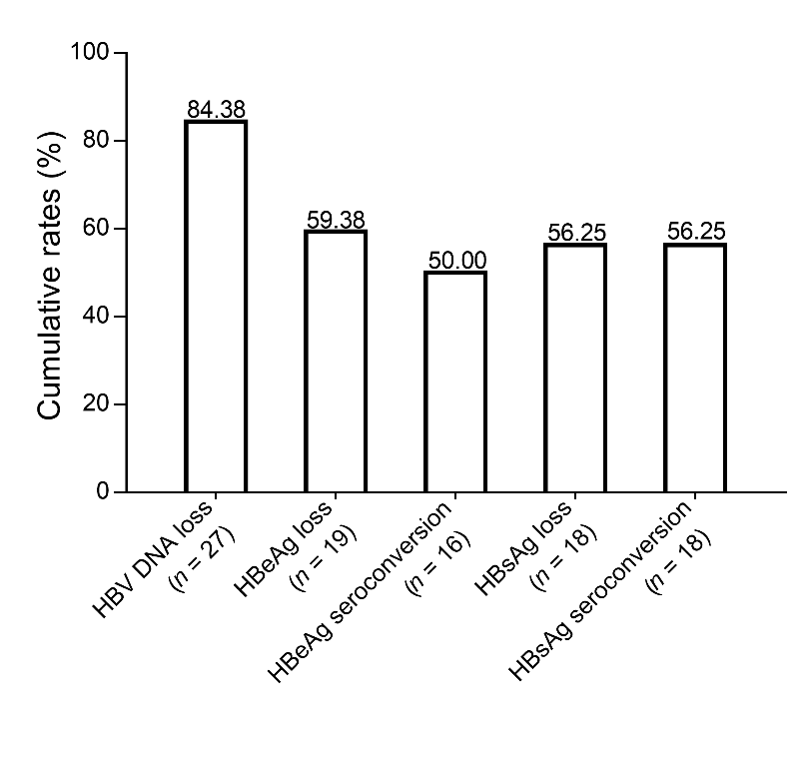

Supplementary Fig. 1. Cumulative rate of serum HBV DNA loss, HBeAg loss and seroconversion, HBsAg loss and seroconversion in the 32 CHB children after 36 months of antiviral treatment in treated group.

