Appendix 5. LOESS-smoothed trajectories of WBC, PLT and qHBeAg
Using the same approach as in the main analysis, we separately constructed LOESS-smoothed trajectories for all WBC, PLT, and qHBeAg measurements collected before and after baseline. qHBeAg values were expressed as log10 S/CO. LOESS fittings were performed piecewise (x < 0 and x ≥ 0), with x = 0 assigned to the post-baseline segment, and 95% CIs were displayed. Overall, the Peg-IFNα-2b add-on group showed a post-baseline “decline-then-recovery” pattern in both WBC and PLT, whereas the NAs alone group exhibited relatively small fluctuations with no obvious trajectory shift across baseline (Figs. S5–S6). The qHBeAg trajectory suggested a more rapid early decline in the Peg-IFNα-2b add-on group during the first 6 months after baseline, whereas the subsequent slopes became broadly comparable between groups (Fig. S7). Analyses were performed in R 4.4.1 (ggplot2 3.5.1).
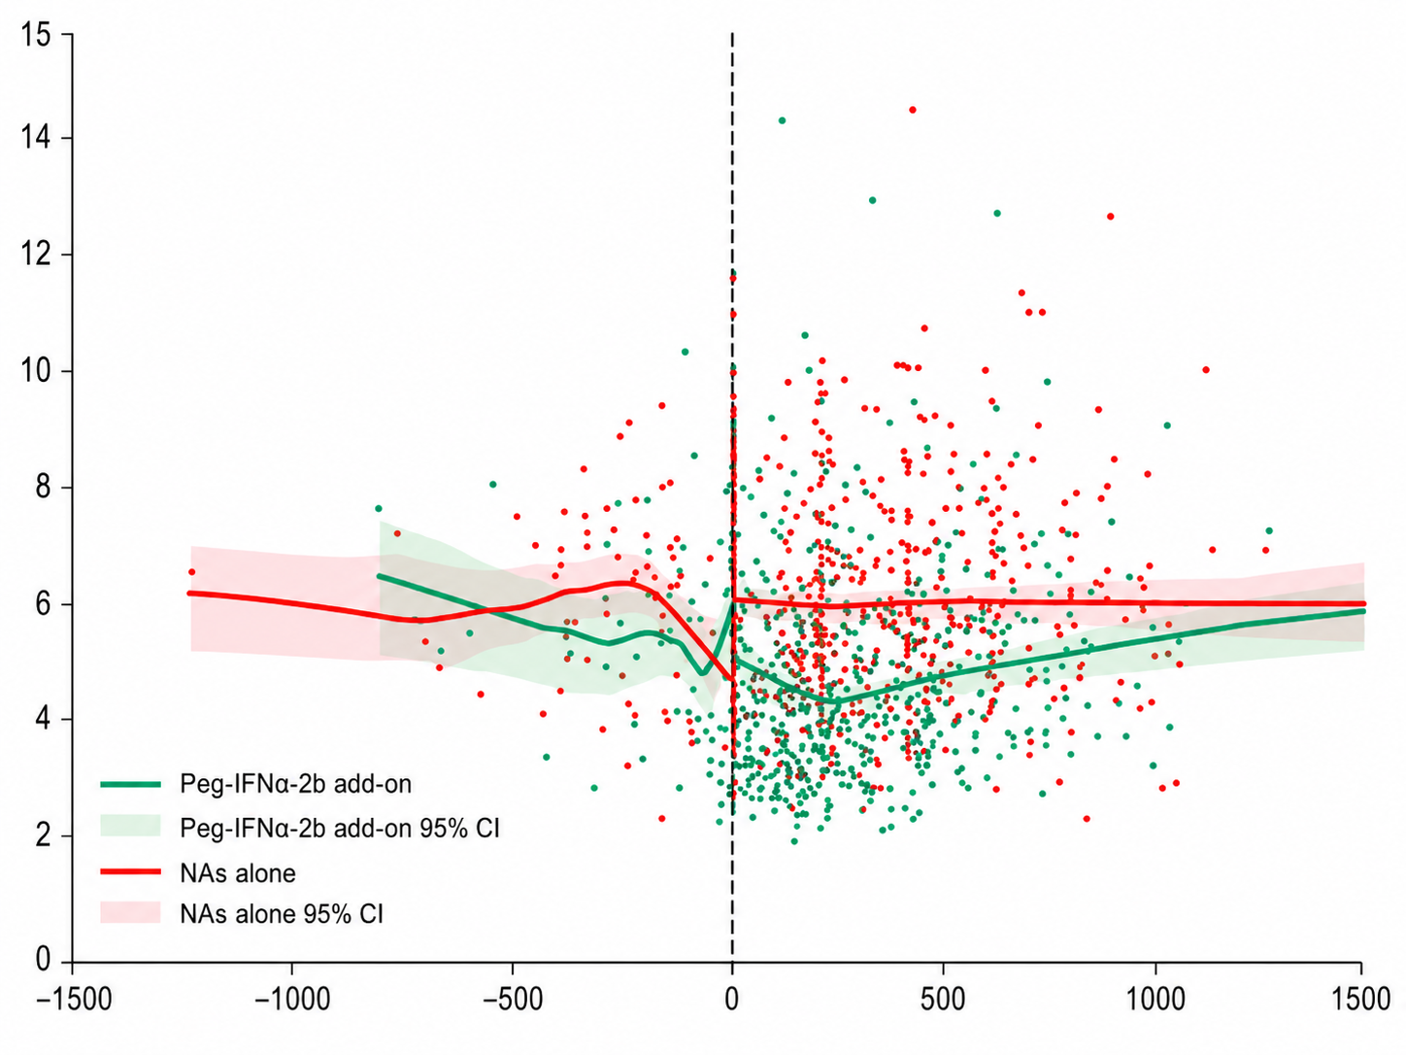
Fig. S5. LOESS-smoothed trajectories of WBC in the two groups.
Points represent individual WBC measurements (green = Peg-IFNα-2b add-on; red = NAs alone). Solid lines denote the LOESS-smoothed fit and shaded ribbons indicate 95% CIs. The vertical dashed line marks baseline (x = 0). The X-axis shows time (days), and the Y-axis shows WBC (×10⁹/L). Number of measurements: Peg-IFNα-2b add-on, n = 620; NAs alone, n = 637.
In the Peg-IFNα-2b add-on group, WBC declined rapidly early after the initiation of Peg-IFNα-2b and reached a fitted nadir around 6 months (3.93×10⁹/L; 95% CI: 3.75–4.08×10⁹/L), followed by a gradual recovery.
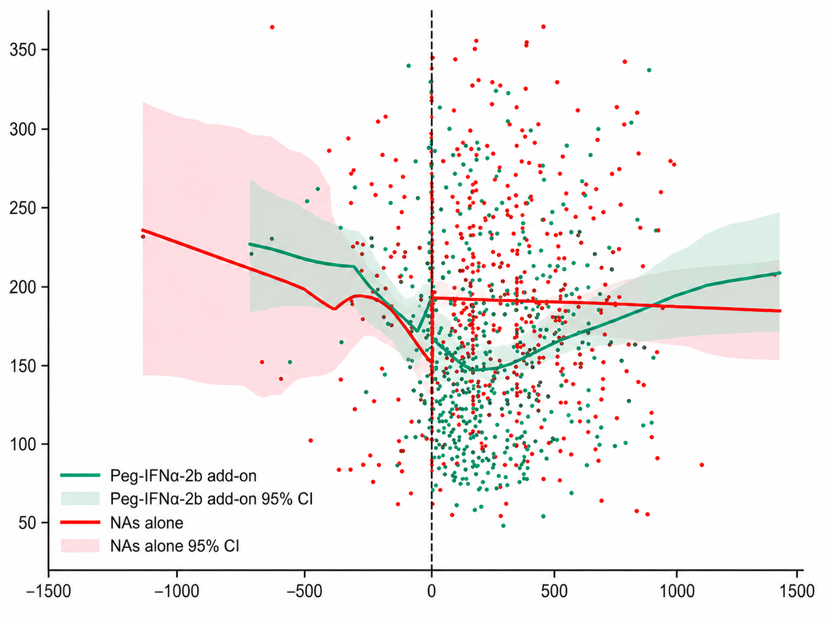
Fig. S6. LOESS-smoothed trajectories of PLT in the two groups.
Points represent individual PLT measurements (green = Peg-IFNα-2b add-on; red = NAs alone). Solid lines denote the LOESS-smoothed fit and shaded ribbons indicate 95% CIs. The vertical dashed line marks baseline (x = 0). The X-axis shows time (days), and the Y-axis shows PLT (×10⁹/L). Number of measurements: Peg-IFNα-2b add-on, n = 620; NAs alone, n = 637.
In the Peg-IFNα-2b add-on group, PLT decreased rapidly early after the initiation of Peg-IFNα-2b and reached a fitted nadir around 6 months (144.98×10⁹/L; 95% CI: 138.32–152.75×10⁹/L), followed by a gradual recovery. In contrast, the NAs alone group exhibited limited fluctuations.
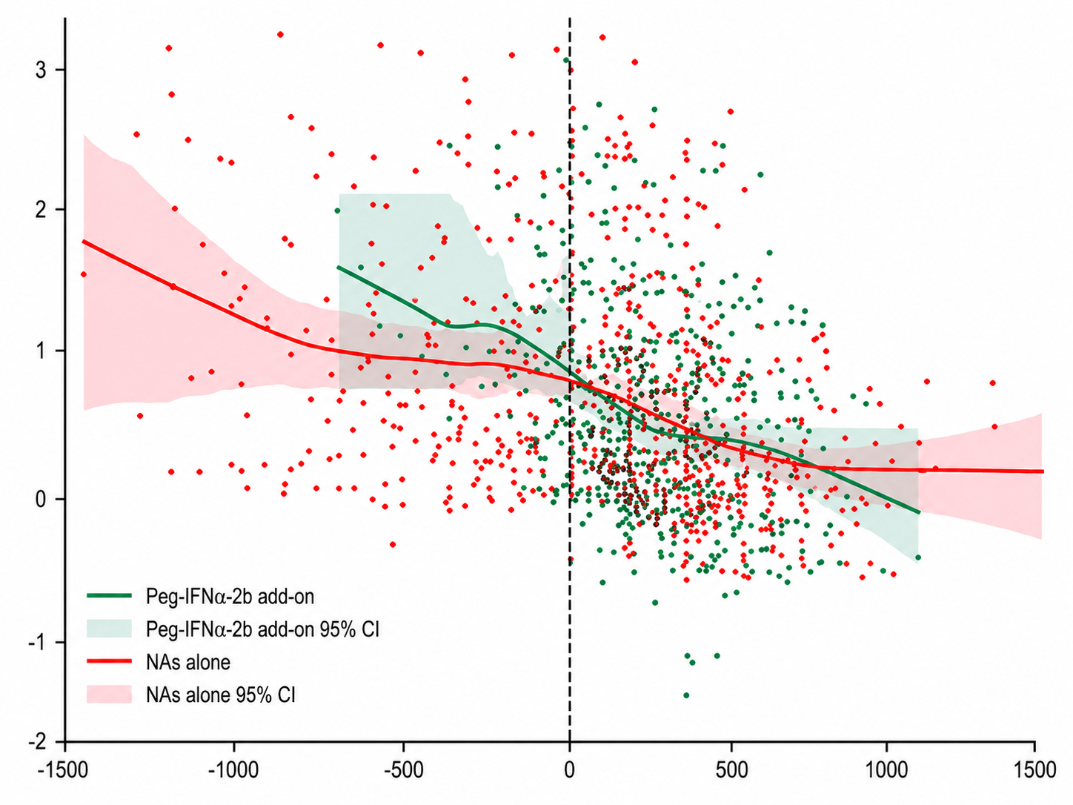
Fig. S7. LOESS-smoothed trajectories of qHBeAg in the two groups.
Points represent individual qHBeAg measurements expressed as log10 S/CO (green = Peg-IFNα-2b add-on; red = NAs alone). Solid lines denote the LOESS-smoothed fit and shaded ribbons indicate 95% CIs. The vertical dashed line marks baseline (x = 0). The X-axis shows time relative to baseline in days, and the Y-axis shows qHBeAg (log10 S/CO). Number of qHBeAg measurements: Peg-IFNα-2b add-on group, n = 563; NAs alone group, n = 604.
The Peg-IFNα-2b add-on group showed a more rapid HBeAg decline during the first 6 months, whereas the slopes of the two groups became broadly comparable thereafter. This later convergence may partly reflect early discontinuation of Peg-IFNα-2b in some patients and the resulting changes in the follow-up population.

