Appendix 3. Method for locally estimated scatterplot smoothing (LOESS)-smoothed trajectories of qHBsAg
Nonlinear alternatives such as generalized additive models (GAMs), spline models, or segmented regression typically require prespecifying basis functions, knot number/placement, or smoothing penalties, introducing a broader model-selection and tuning space and greater sensitivity to modelling choices. Incorporating random effects to account for within-participant correlation further increases model complexity and data requirements, with potential risks of overfitting and reduced interpretability. Given our descriptive, visualization-focused aim and the desire to minimize subjective modelling specifications, we prioritized LOESS for exploratory visualization of qHBsAg trajectories.
We summarized qHBsAg measurements in the Peg-IFNα-2b add-on and NAs alone groups. Time was plotted on the X-axis and qHBsAg (log10 IU/mL) on the Y-axis. Preprocessing included calculating each measurement’s time relative to baseline and excluding records with missing values. To avoid smoothing across the baseline boundary, data were segmented at x = 0 into a pre-baseline segment (x < 0) and a post-baseline segment (x ≥ 0). Within each segment and within each treatment group, LOESS smoothers were fitted using a span of 0.50.
A span value of 0.50 was selected a priori as the primary smoothing parameter because it represents a moderate degree of smoothing for exploratory visualization. It was not optimized using formal model-selection procedures such as cross-validation or AICc, because the LOESS curves were used to describe longitudinal trends rather than to build a predictive model or support formal statistical inference. This value was chosen to balance two considerations: reducing short-term fluctuations commonly observed in real-world longitudinal measurements while preserving the overall temporal pattern of qHBsAg dynamics. A smaller span produces a less smoothed curve that is more sensitive to local variation, whereas a larger span produces a smoother trajectory but may obscure temporal changes.
Uncertainty bands were estimated using a cluster bootstrap at the participant level (B = 200), resampling participants with replacement and retaining all repeated measurements within each resampled participant. For each bootstrap replicate, we refit the LOESS curve and generated predictions on a grid of 400 time points; pointwise 95% confidence intervals (CIs) were constructed using the percentile method, defined as the 2.5th and 97.5th percentiles of the empirical bootstrap prediction distribution.
To assess whether the visualized qHBsAg trajectories were sensitive to the selected smoothing parameter, visual sensitivity analyses were added using alternative LOESS span values of 0.40 and 0.60. A span value of 0.40 represented a less smoothed trajectory, whereas a span value of 0.60 represented a more smoothed trajectory. The overall patterns of the LOESS-smoothed qHBsAg trajectories were similar across span values of 0.40, 0.50, and 0.60, indicating that the visualized longitudinal trends were not materially affected by the choice of LOESS span.
Plots display filled circles (Peg-IFNα-2b add-on = green; NAs alone = red), solid LOESS curves, and semi-transparent 95% CI ribbons; a black dashed vertical line marks x = 0. Analyses were performed in R version 4.4.1 (ggplot2 3.5.1).
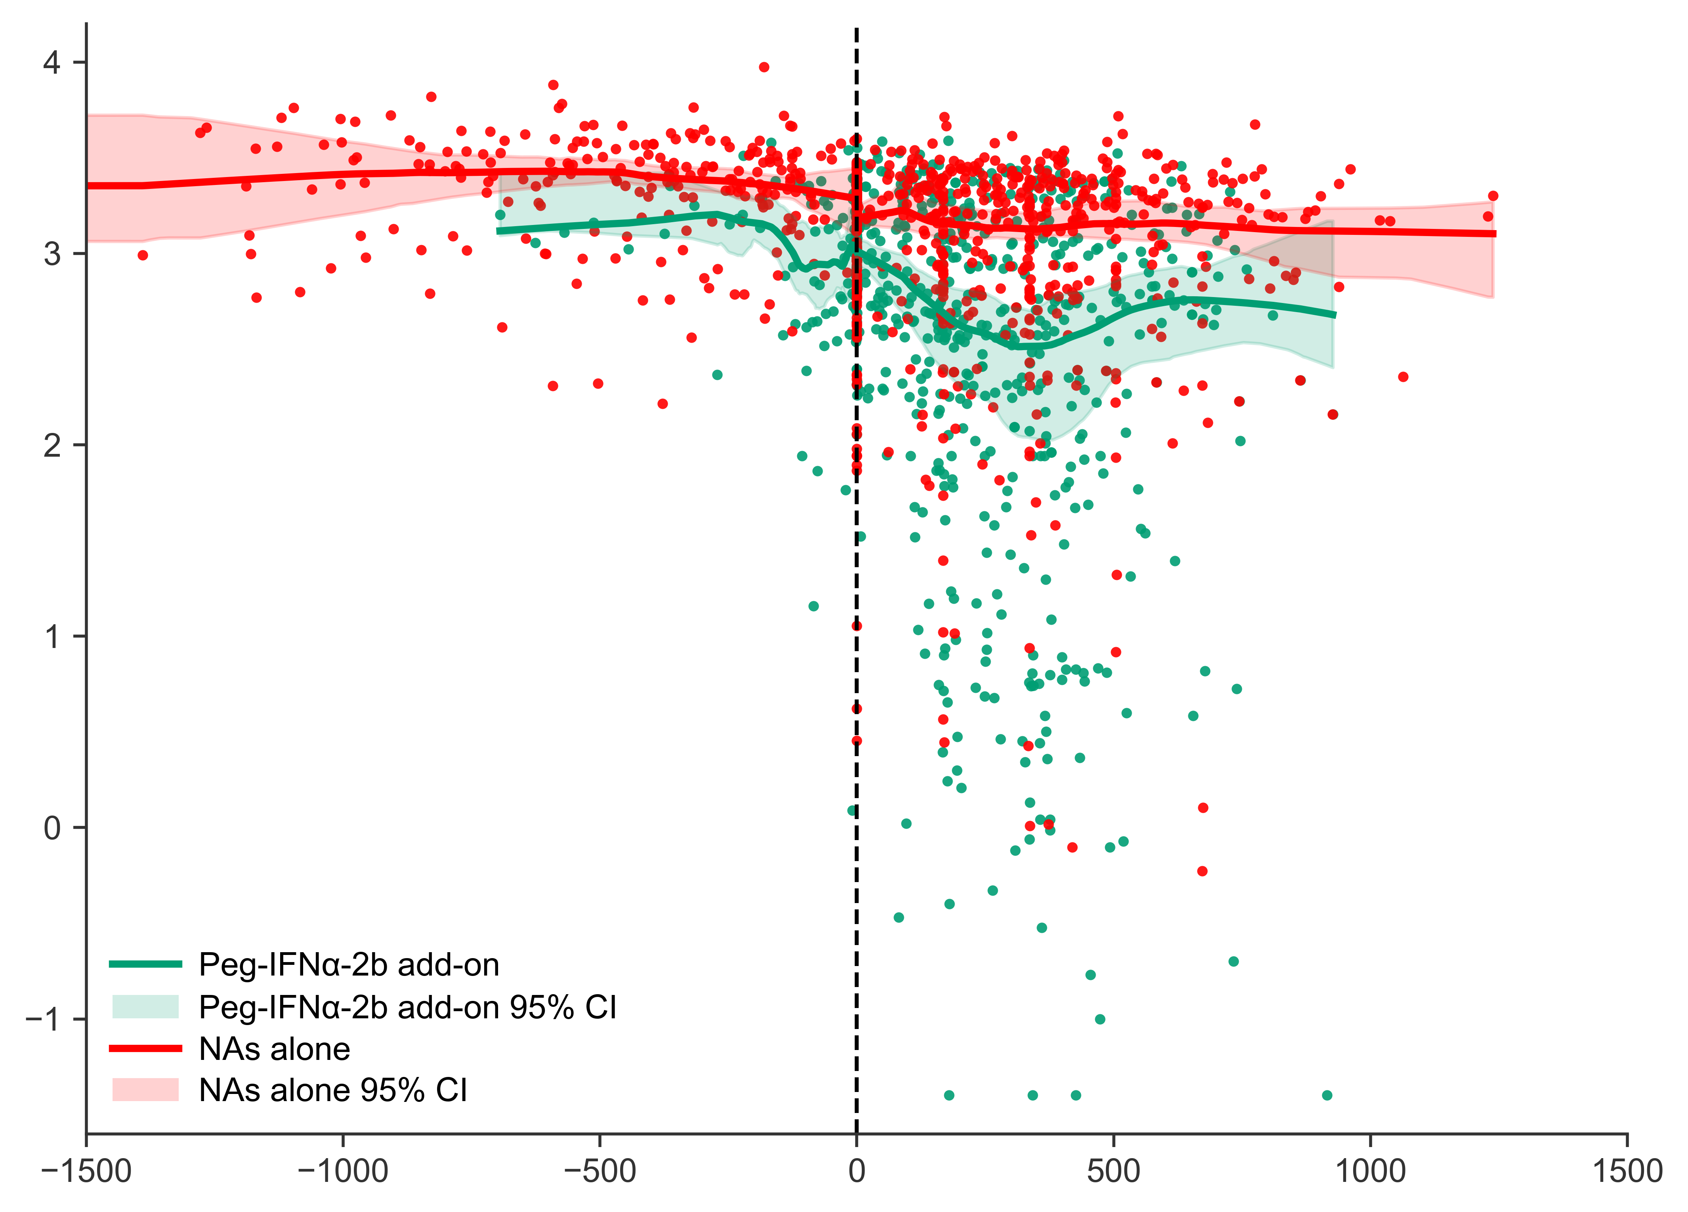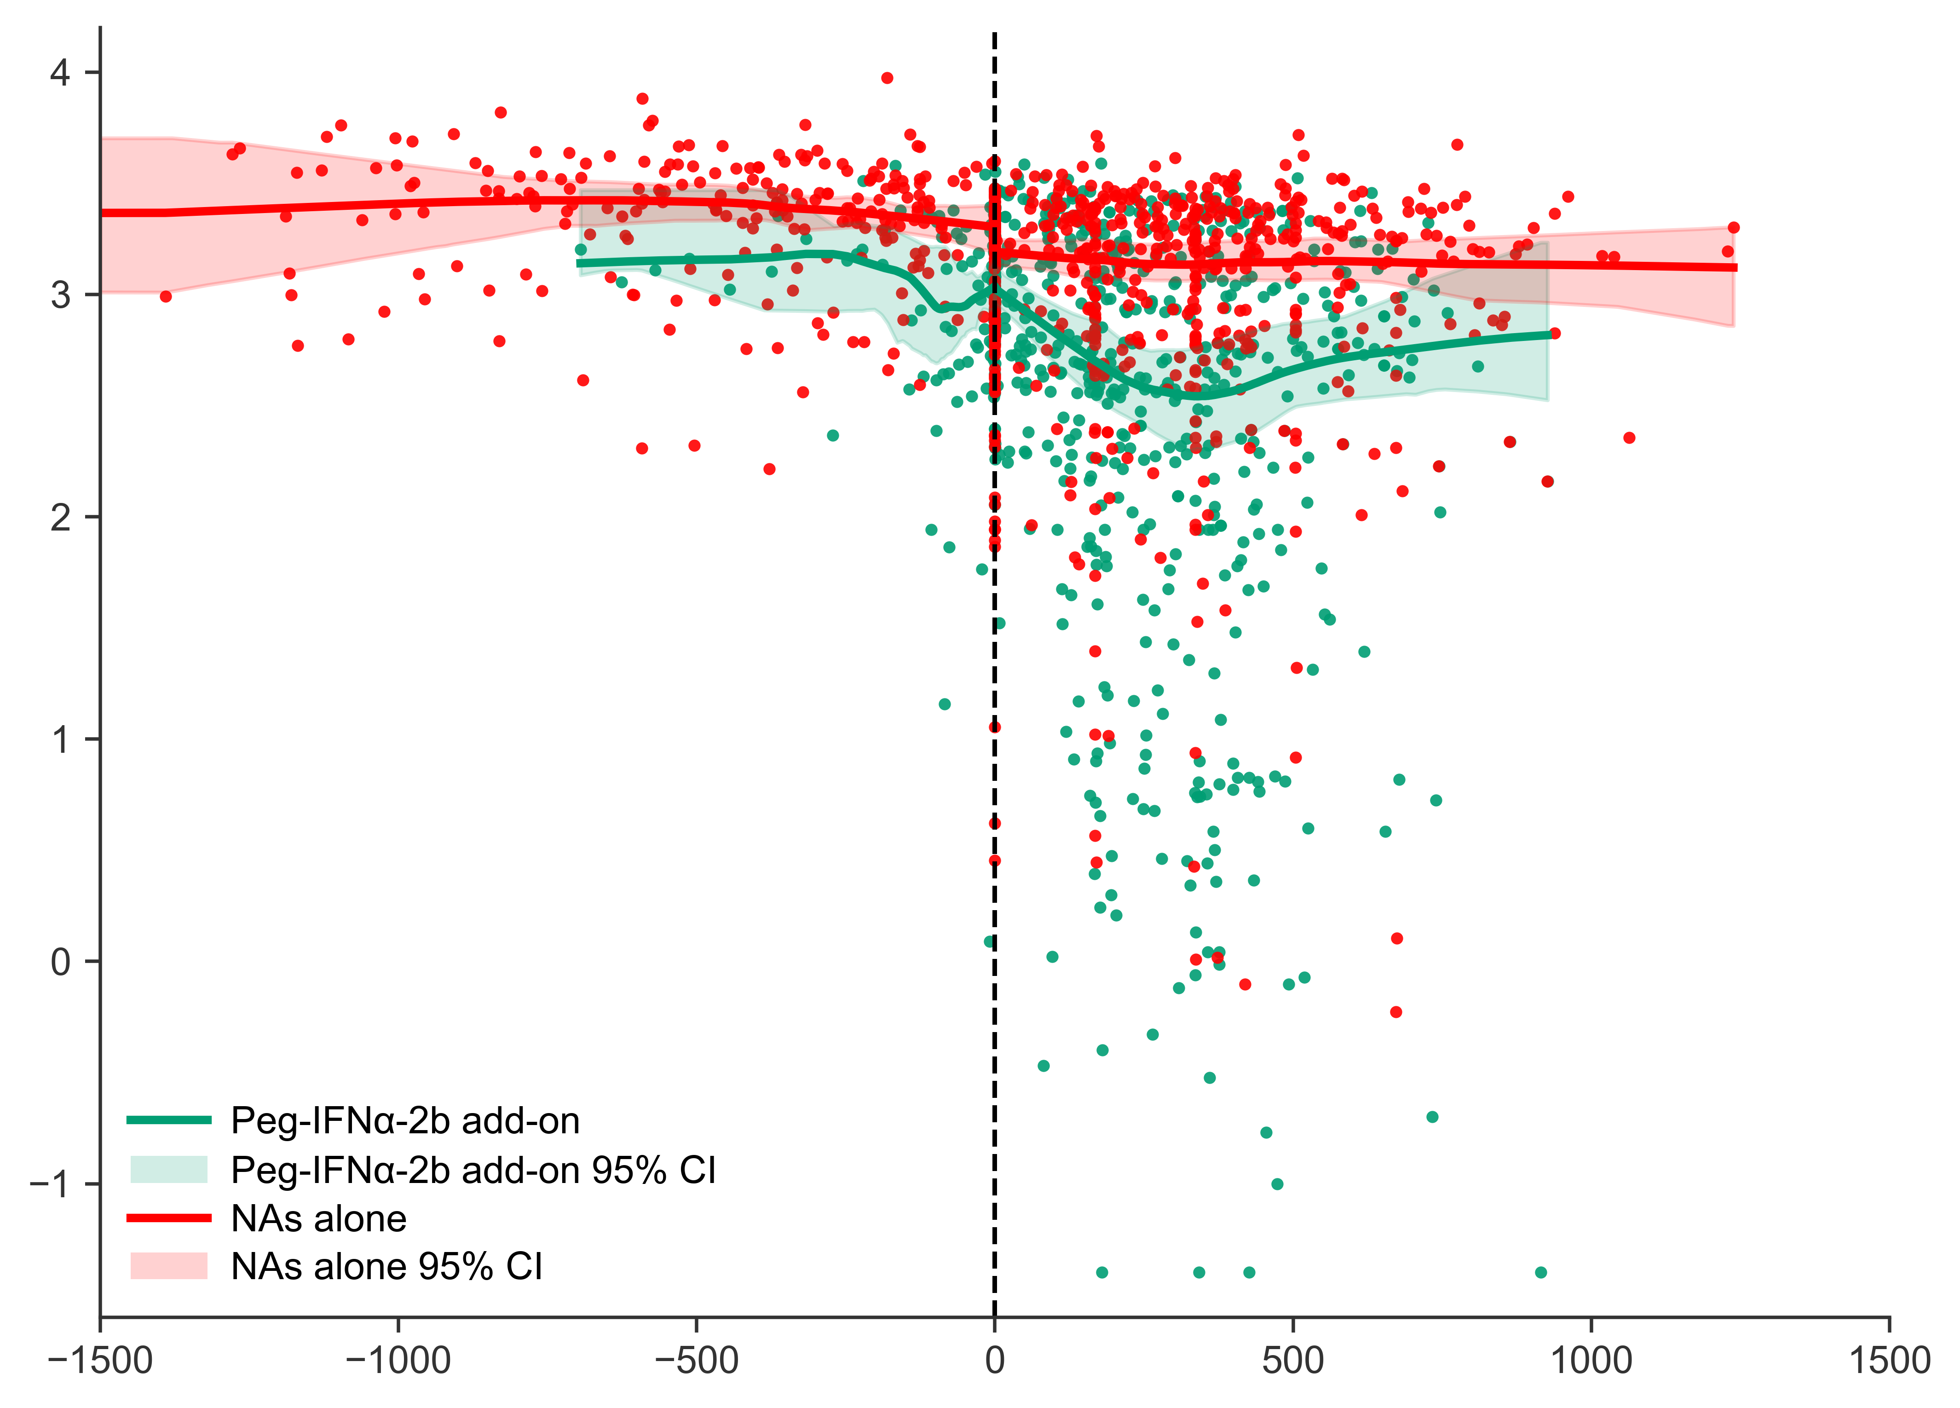
A B
Fig. S4. Visual sensitivity analyses of LOESS-smoothed qHBsAg trajectories using alternative span values.
Panel A shows the LOESS-smoothed trajectory fitted with a span value of 0.40, representing less smoothing. Panel B shows the trajectory fitted with a span value of 0.60, representing more smoothing. Green dots and curves indicate the Peg-IFNα-2b add-on group, and red dots and curves indicate the NAs alone group. Shaded areas represent participant-level cluster bootstrap 95% CIs. The black dashed vertical line marks baseline, defined as x = 0. The overall qHBsAg trajectory patterns remained consistent across the two alternative span values.

