Appendix 2. Propensity-score matching (PSM): methods and results
To mitigate baseline imbalances, we performed PSM to compare the Peg-IFNα-2b add-on group with the NAs alone group, targeting the average treatment effect on the treated (ATT). Prespecified covariates (age, sex, white blood cell [WBC] count, neutrophil count, hemoglobin, platelet [PLT] count, and quantitative HBsAg [qHBsAg]) were entered into a logistic regression model to estimate the propensity score. We then conducted 1:1 nearest-neighbor matching on the logit of the propensity score without replacement, using a caliper width of 0.2 standard deviations of the logit of the propensity score (0.128 logit units in this cohort). Pairs exceeding the caliper were not matched; additionally, we restricted analyses to the region of common support defined by the overlap of propensity-score distributions. Matching order was randomized. Covariate balance was assessed using standardized mean differences (SMDs), with |SMD| < 0.10 indicating adequate balance, complemented by variance-ratio checks and visual inspection of propensity-score overlap. Analyses were performed in R version 4.4.1 (MatchIt 4.5.0, survival 3). Figures were generated in R (ggplot2 3.5.1).
All 161 patients in the Peg-IFNα-2b add-on group were matched 1:1 to patients in the NAs alone group, yielding 161 matched pairs (n = 322); 78.5% of NAs alone patients were retained (161/205). Post-matching balance improved substantially (mean |SMD| = 0.038; maximum |SMD| = 0.059; all covariates <0.10) (Table 1). The common-support interval (propensity score) was (0.138, 0.707) before matching and (0.174, 0.697) after matching, indicating improved overlap in the matched sample. The PSM flowchart is shown in Supplementary Fig. S1; diagnostics are provided in Supplementary Figs. S2–S3.
Fig. S1. PSM flowchart
Table S1. Baseline characteristics before and after propensity score matching between Peg-IFNα-2b add-on and NAs alone cohorts.
Indicators | Pre-matching |  |  | Post-matching
Indicators | Peg-IFNα-2b add-on group  (n = 161) | NAs alone group  (n = 205) | SMD | Peg-IFNα-2b add-on group  (n = 161) | NAs alone group  (n = 161) | SMD
Age (years) | 42.00  (36.00,48.00) | 44.00  (35.00,53.00) | -0.205 | 42.00  (36.00,48.00) | 44.00  (35.00,53.00) | -0.046
Male sex, n  (%) | 135  (83.85%) | 131  (63.90%) | 0.467 | 135  (83.85%) | 130  (80.75%) | -0.052
Hb (g/L) | 151.00  (136.00,159.00) | 159.00  (149.00,168.40) | 0.009 | 151.00  (136.00,159.00) | 148.00  (136.00,158.00) | -0.059
WBC  (×10⁹/L) | 5.67  (4.83,6.63) | 5.57  (4.48,6.60) | 0.152 | 5.67  (4.83,6.63) | 5.46  (4.40,6.55) | 0.007
Neutrophils (×10⁹/L) | 3.05  (2.52,3.88) | 3.00  (2.30,3.78) | 0.144 | 3.05  (2.52,3.88) | 2.92  (2.23,3.80) | -0.036
PLT  (×10⁹/L) | 192.11 ± 62.49 | 191.11 ± 60.36 | 0.017 | 192.11 ± 62.49 | 188.80 ± 59.90 | 0.056
qHBsAg  (log10 IU/mL) | 3.05 (2.78,3.27) | 3.16  (2.88,3.30) | -0.136 | 3.05  (2.78,3.27) | 3.15  (2.56,3.30) | -0.010
Note: Data are presented as mean ± standard deviation (SD) or median (interquartile range) as appropriate.
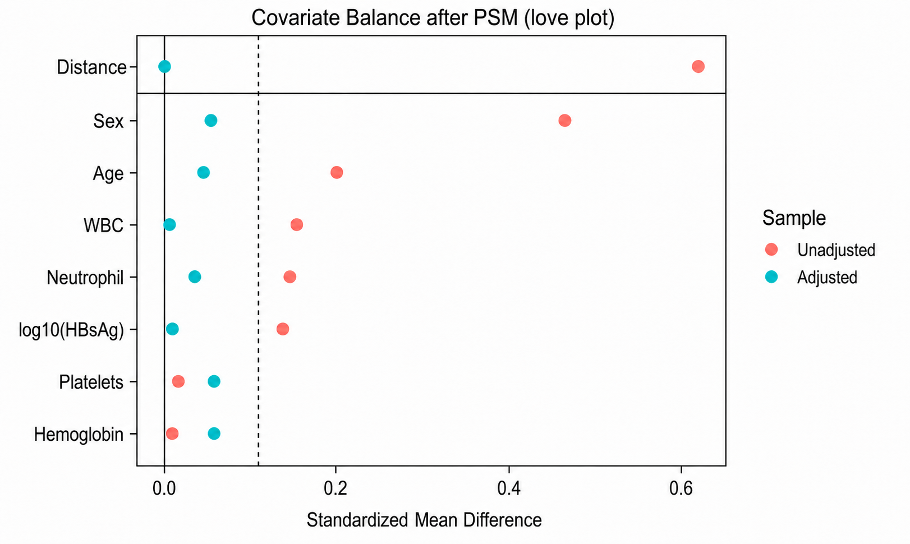
Fig. S2. Love plot
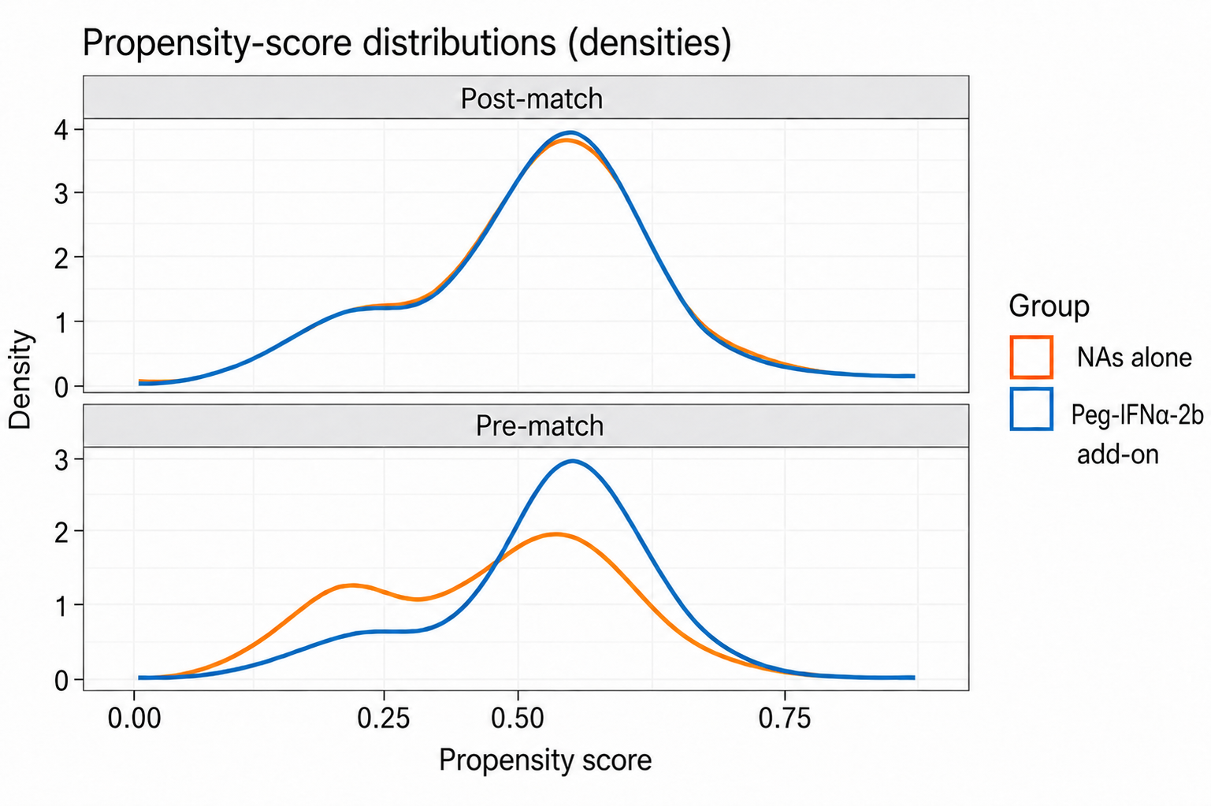
Fig. S3. Propensity-score distributions

