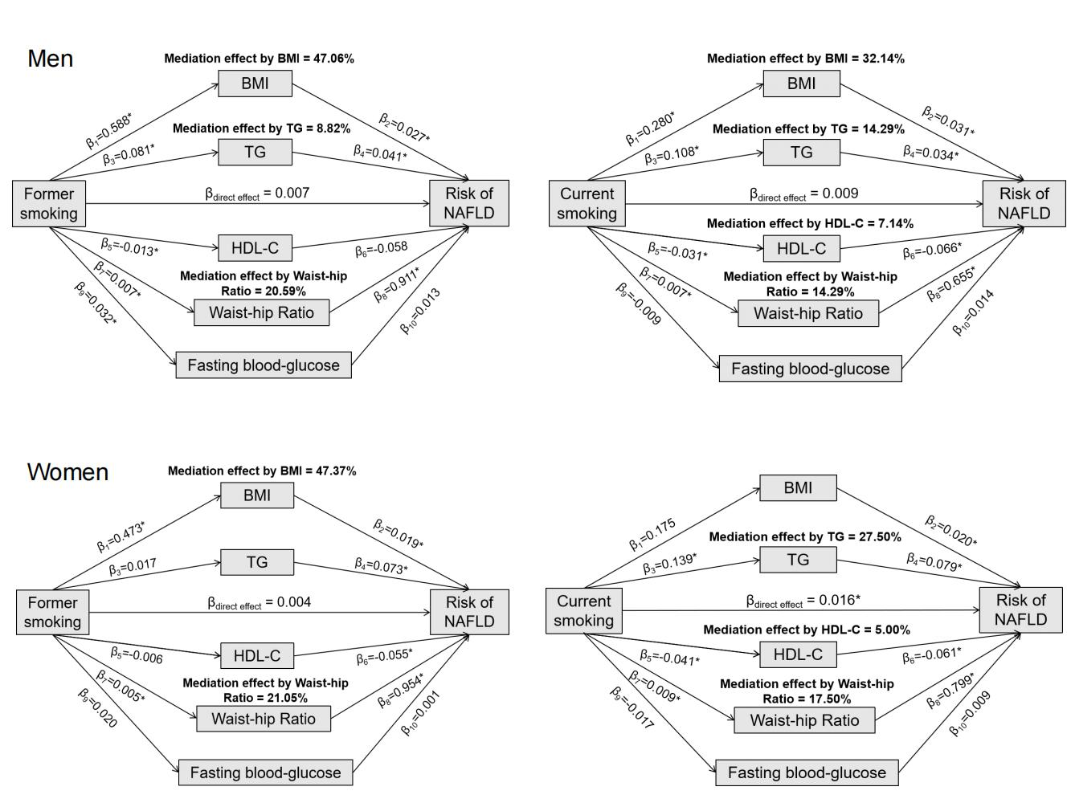
Supplementary Fig. 5. Mediation effects of BMI, TG, HDL-C, FBG and WHR on the association between different smoking status and risk of nonalcoholic fatty liver disease by sex in UK Biobank. *p < 0.05 for coefficients different from 0. Data are regression coefficients with adjustment for age, ethnicity, physical activity, education level, and drinking status. BMI, body mass index; HDL-C, high-density lipoprotein cholesterol; NAFLD, nonalcoholic fatty liver disease; TG, triglycerides.

