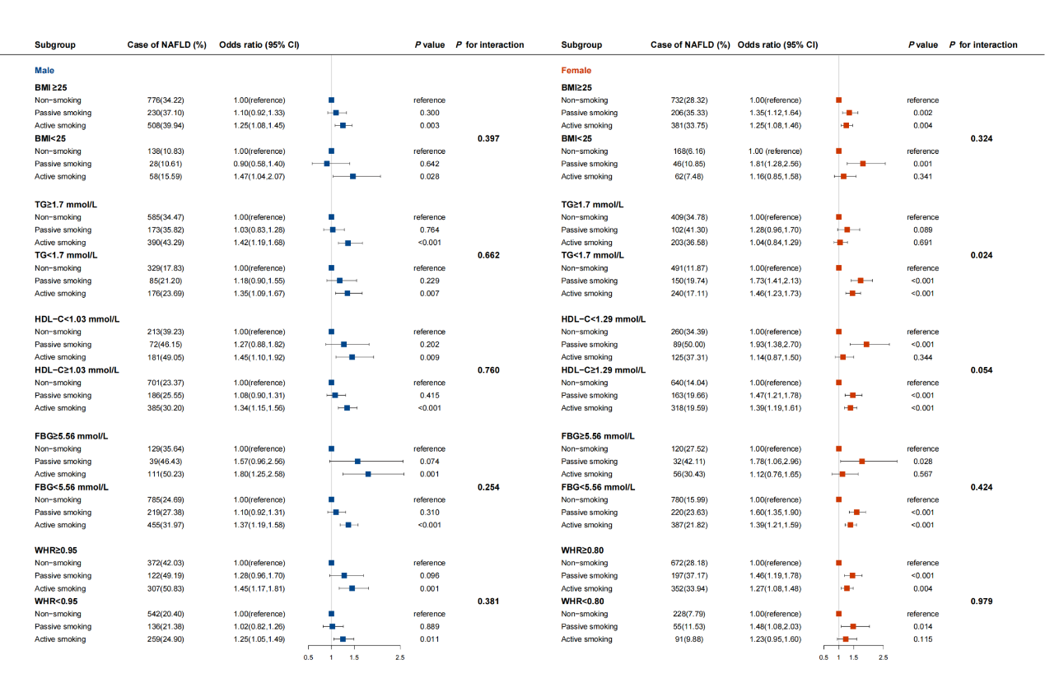

Supplementary Fig. 3. Association between smoking status and risk of nonalcoholic fatty liver disease stratified by BMI, TG, HDL-C, FBG, and WHR in UK Biobank. BMI, body mass index; FBG, fasting blood glucose; HDL-C, high-density lipoprotein cholesterol; NAFLD, nonalcoholic fatty liver disease; TG, triglycerides; WHR, waist-hip ratio. Risk estimates were adjusted for age, ethnicity, physical activity, education level, and drinking status.

