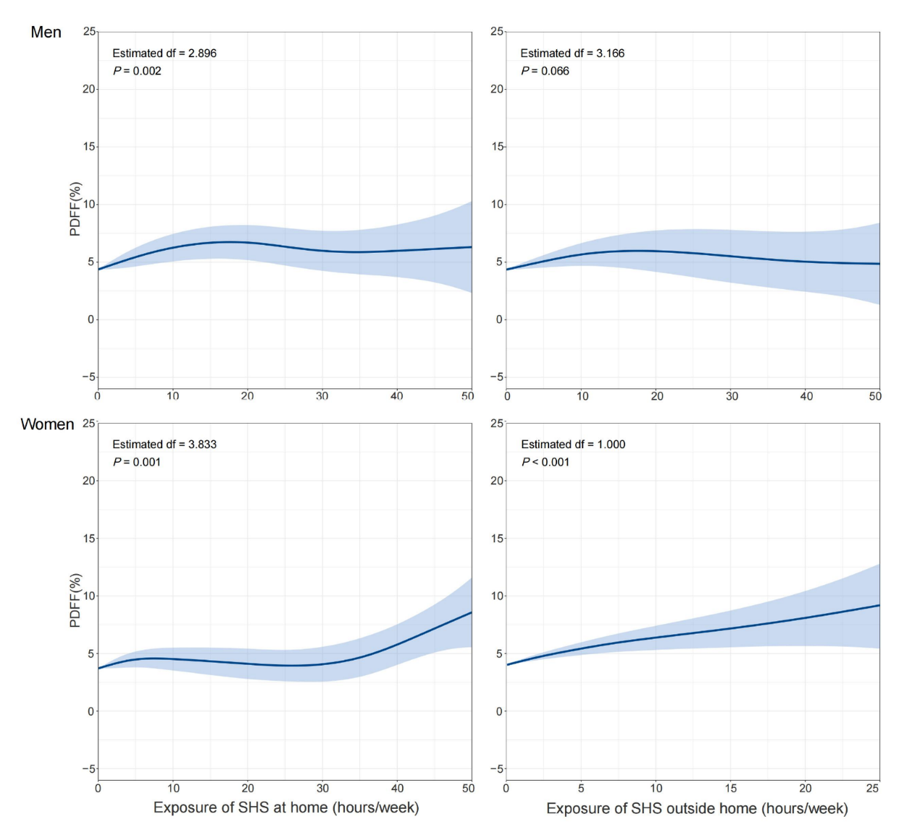
Supplementary Fig. 2. Nonlinear relations between exposure to secondhand smoke and value of liver PDFF among never-smokers in UK Biobank. PDFF, proton density fat fraction; SHS, secondhand smoke. Generalized additive models were used to estimate degree of freedom and p-values.

